**Mail Services Department at Stockton University Final Report**

Current System Analysis and New System Proposal



Group 1

Justin Winter

Eric Einhaus

Austin Russo

Raymond Madden

**Project Overview**

Executive Summary:

The goal of this project is to analyze the current package handling system for the Mail Service Department at Stockton University, find problems with the current system, and find solutions those problems with the help of user interface and automation.

Roles:

**Justin Winter** - Team Leader, Diagram Descriptions, Meeting Organizer

**Eric Einhaus** - Process Modeling, Project Repository, Report Organizer

**Raymond Madden** - Output Design for New System, Meeting Minutes, Process Specification Forms

**Austin Russo** - Presentation Slides Organizer

Contents:

* Phase 1 Report
  + Business Description
  + Process Modeling
  + Phase 1 Presentation
* Process Modeling
  + Diagram 0 and Child Diagrams
* Project Repository
  + External Entities, Processes, Input, Output, Data Stores
* Process Specification Forms
* User Interface Design for New System
* Visible Analyst Report
* Appendix
  + Signed Team Contract
  + Team Weighting Contract
  + Meeting Minutes
  + Final Presentation

Current System for the Mail Services Department at Stockton University

**Phase 1 Report**



Group 1

Justin Winter

Eric Einhaus

Austin Russo

Raymond Madden

**Part One: Business Description**

**Organization Name:** Stockton University

**Name of the System:** Mailing System

**System Description:**

The purpose of the system is that it is a service for Stockton University residents to pick up postage mail and packages.

**About Stockton University:**

Stockton University is a public University of higher education, providing its students with a liberal arts education for its undergraduate and graduate studies. 8,000 students are currently enrolled at Stockton, with campuses and offices located in Galloway, Atlantic City, Manahawkin, Hammonton, and Woodbine, New Jersey. Stockton University was established in 1969, named as the Richard Stockton College of New Jersey, and the first batch of students enrolled in classes during 1971. The main goals of Stockton’s educational program is to provide its students with a liberal arts background, to provide its students with a well-rounded education. Stockton University’s main Galloway campus is located on 101 Vera King Farris Drive in Galloway, NJ.

**Current Subsystems of Stockton University:**

* **Registration:** Sign up with an application, which gives you a chance to be enrolled successfully at Stockton
* **Residential Life:** Provides students with housing on campus, as well as desired maintenance and requests by the student.
* **Academic Affairs:** This service checks to see if the student is in good standing, so they can still be enrolled as a student and be provided with beneficial services.
* **Student Records:** Keeps records on all the information of any given student, to see if they are graduation eligible and have the required GPA.
* **Admissions:** Responsible for admitting new students and transfer students to Stockton.
* **Mail Services Department:** Responsible for receiving packages of students, organizing them, and preparing them for student pick-up. Also responsible for letter mail services.

**About the System:**

The Stockton University Mailroom was founded at the same time of the University’s growth in the 1970’s. The main goal of the Stockton University mailroom is to transport packages and postal mail from sender to receiver (and vice-versa). This service is convenient for students, so it eliminates the inconvenient task of going to an off-campus post office to pick up and send out mail and packages. The company is run by 5 full-time employees and 20 part-time students. Thus, the size of the company is small to medium sized.

The system itself likely went unchanged since its construction, and it seems to work well to the present day. People (students or faculty) pick up packages via a postal truck and are placed into either a PO Box or through a customer service window if it is a package (the student is notified in some way, but likely was not by email when it first opened). This continues in a cycle each day until it closes at night. Nothing has likely changed since its current setup was devised.

***Summary of Business Activities***

**Part 1: Packages**

* UPS, USPS, and DHL (companies that deliver packages for consumers) drop off packages at Stockton University unloading zone.
* Packages are transported from truck outside to the mailroom inside via mobile blue bins by mailroom employees.
* Once in the mailroom, packages are individually checked for any damage or informalities.
* Mailroom scans barcode on package for tracking purposes.
* For packages, using the MSC number (MSC is the student’s PO Box number, unique to each Stockton residential student) and name of the student on the package address, a new label is stuck on the package, with an auto generated zone made by the notification system. This label is scanned later when student picks up package for recording purposes.
* Once package is recorded in the system with the MSC number and the zone number, an email is sent to notify students, stating the zone where the package is in (provided it doesn't fit in the post box).
* Student Picks up packages from the pickup window.
  + Students express what zone their package is in
  + Student gives the mailroom employee their student ID for verification services
    - The student’s name, Z-number, and photo-ID are on the Stockton ID card
  + Employee, using the name on the ID, looks for the package(s) in the specified zone.
  + Employee gets package(s) from dedicated zone.
  + Employee scans label, showing package details and recording date and time on their software.
  + Student uses their signature to show verification that the package(s) is getting picked up.
  + Student leaves with the proper package(s).

**Part 2: Letter mail and Small packages**

* Mail is sent out by companies addressed to Stockton University.
* Employees of the mailroom pick up mail from the USPS post office located in Absecon, NJ.
* Mail is transported to Stockton at designated unloading spot.
* Mailroom employees used mobile blue bins to unload mail and transport it inside the Stockton Mailroom.
* Mail is organized into sections and mail boxes, using the MSC on the address line to find what exact mailbox the mail/small packages goes to.
* Students pick up mail from post box, without notification.

**Problems**

* Small packages and letter mail give no notification to the student who is receiving the mail. This would cause a buildup as the average student would likely be unaware that there is mail in their mailbox, which they manually must retrieve.
* The system uses a notification system primarily based on the student’s Gmail, an email service provided by the institution. However, there is currently not a notification system using text messages. Text messages are more likely to be seen first by the student rather than the email sent out.
* Student’s seem to complain about the length of the line at times for picking up packages.
* There may occasionally be package damage due to mishandling during transport, misplacement, temperature, etc.
* If the MSC number is not present on the package for a person who shares the same name with someone else
* Possible delays due to either inclement weather, vehicle problems, or emergency closure of the mailroom, and power outages.

**Opportunities**

* The Post Box could be improved if it has more efficient capabilities. Such capabilities can include faster notifications for overflow in the Post Box, which can include text messages, an automatic email, or other forms of notification. They could also hire a new section of people designated specifically to check mailboxes every day to see how full they are and take proper action if any mailboxes are full.
* Another opportunity is to add a text messaging system for students who would want to opt it for it. Emails are more likely to be unchecked than text messages, especially to millennials that are enrolled in the institution. The text message system would be automated just like the current email push system and would be an optional service for students.
* Better Customer Service would be useful, especially given that there sometimes are long lines for package pickup. To fix this, more people could run the packages to the customers to make it more efficient and shorten the line faster, and of course they would check all the proper items before handing them over.
* The line could be shortened with the adaptation of an online queue system, allowing students to pick up packages at a scheduled time, and thus the packages would be ready to be picked up without a wait.

**Objectives**

* Increased customer satisfaction
* Smoother and cleaner package pickup. More organized pickup with small variations per week
* Better notifications and/or texts
* Reduced wait time and schedule to remove the long and tedious lines

**Business Case**

Should the mailroom choose to apply our new information system, several benefits would occur. The new system will provide a queue system for students to pick up their packages. Specifically, a student can pick up a package at a specific time, and using a newly implemented express line, pick up their package right away. By adding the queue system, this enables faster preparation, as when a student arrives to claim their packages, it would already be found and only has to be spotted within the group of packages in the same time slot (which means time slots can allow for up to a select number of people). An express line added to alongside with the normal line would allow services to be done more faster so students could go along with their day.

The new system would also get students to be notified by email, text message, and other means of communication when a package is waiting for them in the mailroom. Millennial students, that take up the majority of the student body, rely on text messages as their main source of external information. Thus, with the addition of the new text messaging notification system, it would allow students to get the message more faster than by email. This would also allow packages and letter mail to be picked up faster.

Overall, there will be more of a direct link between the mailroom and the student, and packages will in theory be picked up much faster with the text message notification and the queue system being put into place. Packages of any size and letter mail would be more efficiently distributed, and thus students would be able to retrieve it faster.

**Information Requirements**

The mailroom currently uses the student’s name, their Gmail account and their mailbox number (MSC), the latter being used to help find and get their package. All this information is linked so that letters can be placed in the correct mailbox and the packages are placed in the correct zones. The MSC is used for packages, unique to each student, to find their desired Gmail address and sent out the notification that a package is ready. Their name, the zone number (from the Gmail), and the MSC (mailbox number) are used by the employee to find the package(s) for the student. The new system will need an optional phone number and all the information as stated above to provide a new efficient service for students to pick up their mail and packages.

A new queue database will be needed to schedule appointments for students to pick up their packages convenient and faster. A select number of students can register for a certain block of time to pick up their package (5-10 people depending). The blocks will be between and including 10-20 minutes, given the process of picking up packages, as well as how many packages a student can claim at a given time.

**System Needs**

*The following is a summary of the new business activities in the new proposed information system.*

* A text message/notification (if student is opted into the system as a text message recipient) is sent to notify students, stating the zone where the package is in (provided it doesn't fit in the post box).
* Student optionally can request a time when to pick up the package via the goStockton Portal, located on the link in the email. Another way to queue a time is by messaging back a time on the text message.
  + If a student queues a time, it is recorded automatically by a newly implemented queue system and inside a schedule database. Package is moved by employee to a convenient location, ready for fast and easy pick up. Package will have a new label stating the time of the pickup.
* Student picks up packages from the pickup window.
  + Student uses either the normal line or an express line for those with a pick-up time.
  + For non-queued packages, Student expresses what zone their package is once it’s their turn, gives student ID for name and Z-number for verification.
  + For queued packages, Student’s simply state their name and time of pickup.
  + Employee gets package from dedicated zone. If packages have been queued, there will be a close-by convenient location (zone), so the package will get to the student faster.
  + Employee scans label, showing package details and recording date and time on computer.
  + Student signs their signature on touchpad to show verification that the package is getting picked up.
  + Student leaves with the proper package(s). Queue is deleted automatically from the system if a queue was used, but information stays (possible liability if not kept).

**Part 2: Letter mail and Small packages**

* Before the letter mail is placed into the mailbox, an employee inputs the MSC number on the address line via a mobile device into the system.
* The MSC number will coordinate with the student’s email and phone number (if student opts into text messaging notification service). The system will then send out an email and text message (optional) stating that there is mail in their mailbox, ready to be picked up.
* Students pick up mail from mailbox, no signature is needed.

**Part 3: What will the system utilize?**

* The system will use the following:
  + Gmail will remain from the old system for notification.
  + A new application for automatic text messaging will be used by the mailroom to notify students when a package is ready. This will be an optional service.
  + The Queue system will be utilized on Stockton’s own goStockton Portal. There will be a link, under Student Services, to a new application that allows students to make an appointment to pick up their package and allow permission to use the implemented express line.
  + A new mobile application by the mailroom will be implemented, allowing the input of a student’s MSC number to notify them of letter mail being ready to be picked up.

**Part Two: Diagrams and Descriptions**

The following are the diagrams made in Visible Analyst during Phase 1.

(Note: A horizontal line indicates a bridge from one diagram to the next)

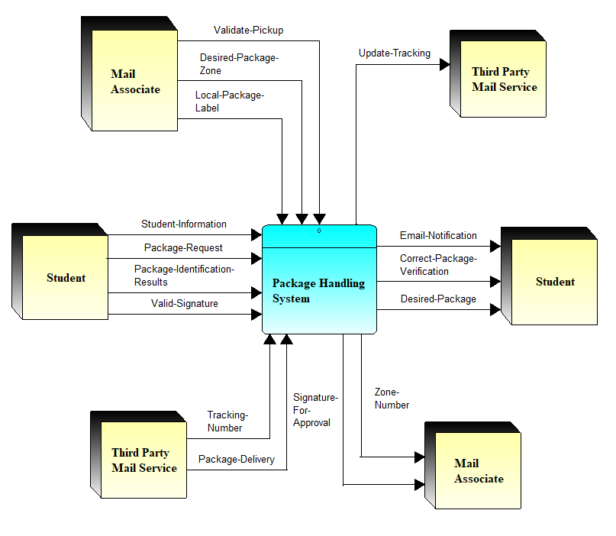

In this **Context level Diagram**, the system being looked at is the Package Handling System. The three External Entities that interact with the Package Handling System are the Students, Mail Associates and Third Party Mail Services such as DHL, UPS, and Fed-Ex. The students information is given to the System to determine if they are in fact a student who can receive their package at the mailroom. From here the Student can request something from a third party mail service, and the third party mail service will proceed to send the package to the package handling system. From here when the package then arrives, a email notification gets sent to the student with information such as what zone there package is in and other information such as the students name and Z number for other use for filing. The student can now proceed to the Mailroom and request the package. The students emailed Zone number is then used to find and validate the package which is now sent back to the package handling system. The desired package is then handed to the student, the students signature is given to the Package handling system, and the signature is the given to the mail association for record.

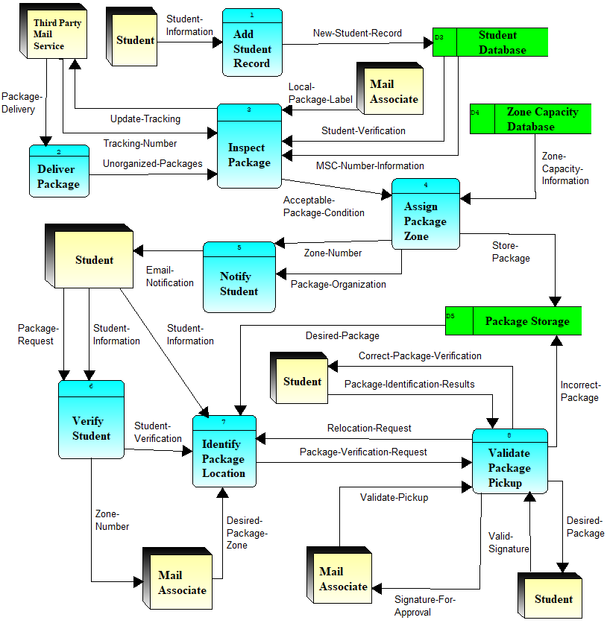

Above shows the **Diagram 0** of the Packaging Handling System. In this diagram, the two initial interactions that needs to be done for the system to process is from the students and from third party mail services. The processes begins with the student and their information, as there information is used to add the student to the database, and their information is then used when the mailroom inspects the package. Before they can inspect a package they first need to receive a package. The third party mail service such as online stores like Amazon, Ebay, USPS, or UPS. The new package is then sent to be inspected, inspecting it with information from the student database. Once the package is deemed acceptable for the mail room, the package is then assigned a zone which is added to the Package Zone Database (storage). The information is then sent to notify the student of a package in the mail room ready to be picked up. The student provides the desired zone and the student ID to find the Desired package. The students information is cross checked with the Package Zone Database to determine if this student is the student the package is for. Once the student is validated to pick up package, the Mail association receives a signature to signify their package was received and then the package is given to the student.

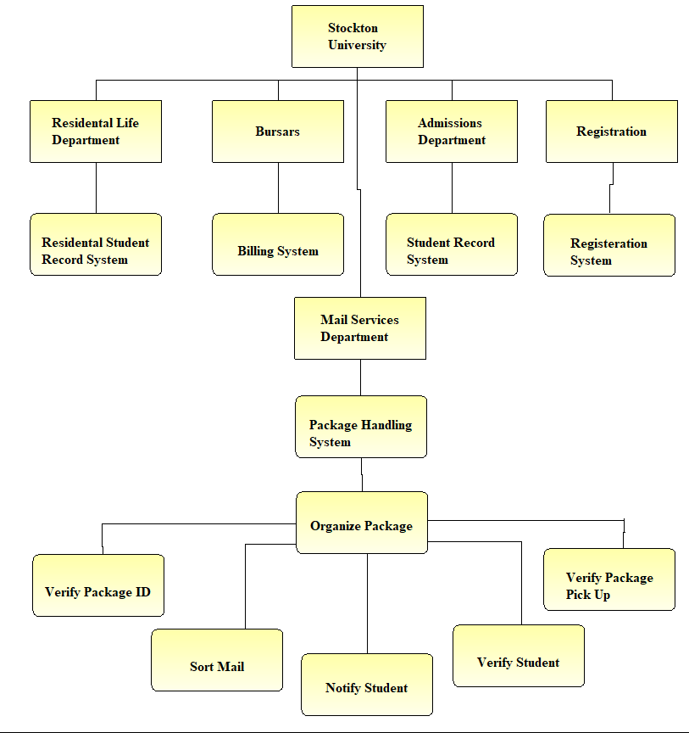

In the **Functional Decomposition Diagram**, we look at Stockton University who has 5 distinct departments, Residential Life Department, Bursar's Office, Admissions Department, Registration Department, and lastly the Mail Services Department. Each Department Breaks down into its own systems, The Mail Services Breaks down into the Package Handling System. In the Package Handling System, there is one process that is Organizing Package, In this process, there is many subprocesses that needs to be met for the process to function, the subprocesses are as followed, Verify Package ID, Sort Mail, Notify Student, Verify Student, and lastly Verify Package Pick Up. With one of these subprocesses missing, the process and system will not be able to function to its fullest.

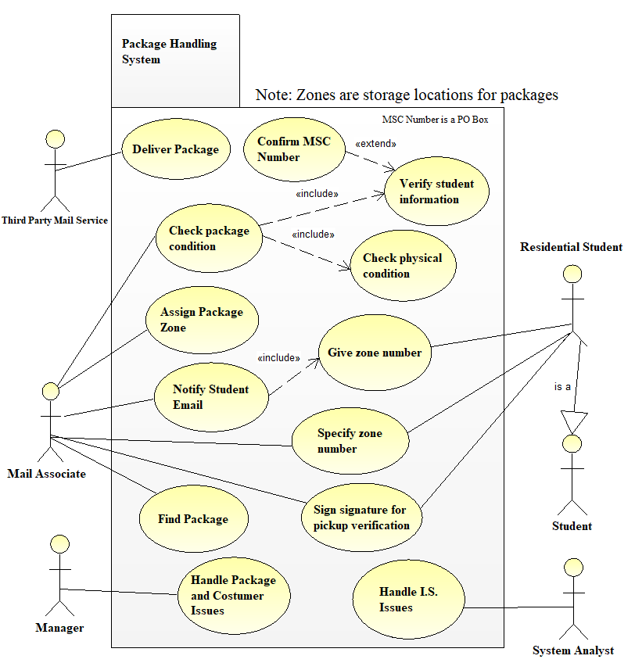

In the **Use Case Diagram** above, there are 3 main actors, Third Party Mail Services, Mail Associate, and Residential Student, which is considered a Student. The Third Party Mail Services only have one job to do, and that job is to deliver the package to Stockton. On the package address, there is a MSC number which extends the verification of the students information. The mail association needs to check the packages condition, but to do this they need to include the information if verifying the students, as well as check the physical condition of the package. Once this is done, the Mail Associates also needs to assign the package a zone and notify the student of the packages arrival and its zone number. When the student arrives they provide the mailroom with the zone number and a signature for the package. The Mail Associate has one final process which is finding the package in the specified zone. And with that the actors each completed there assigned jobs and the System can now restart. There are two supporting actors in the use case diagram, which are the Manager and the System Analyst. The Manager handles any issues dealing with package handling and customer concerns.The System Analyst, from the IT department at Stockton, would handle any issues dealing with the Information System of the mailroom, specifically if the system would to ever be flawed or not working.

**Part Three: Use Case Scenarios**

The following are five different use case scenarios for five important processes of the Packaging Handling System.

**UniqueID:** Chk Pkg Con 001

|  |  |
| --- | --- |
| **Use Case Name:** | Check Package Condition |
| **Area:** | Packing Sorting |
| **Actor(s):** | Mail Associate |
| **Stakeholder:** | Student, Manager |
| **Level:** | Blue |
| **Description:** | Check the physical condition of the package and confirm that the package is addressed to a Stockton University Residential Student. |
| **Triggering Event:** | The package is dropped off by a Third Party Mail Service to the mailroom sorting area. |
| **Trigger Type:** | External |

|  |  |
| --- | --- |
| **Steps Performed (Main Path)** | **Information in Steps** |
| 1. Unloaded Packages from Third Party Mail Service enter sorting area in mailroom. | Package Delivery Verification |
| 2. Mail associate checks the physical condition of the package and checks for any critical damage. | Physical Package Confirmation |
| 3. Package is scanned for verification and tracking purposes. | Recipient Address, Tracking Number |
| 4. Information from the recipient’s address is extracted and inputted into the system. | Recipient Address |
| 5. Student Database is checked comparing to recipient address to check to see if it is for a Stockton Student. | Student Information, Recipient Address |
| 6. MSC Number of address line is checked using the Student Database to see if it correlated with a Stockton Student. | Student Information, MSC Number |
| 7. Label with barcode correlating with MSC number is pasted on package (used in verifying student at student pickup). | Condition Approval, MSC Number |
| 8. Package is passed on to zone assigning system. | Condition Approval, MSC Number |

|  |  |
| --- | --- |
| **Preconditions:** | Package is dropped off at Stockton University by Third Party Mail Service. |
| **Postconditions:** | Package physically is acceptable and belongs to a Stockton Student. |
| **Assumptions:** | Package is addressed to Stockton University. |
| **Success Guarantee:** | Package is acceptable and can be assigned a zone for student pickup. |
| **Minimum Guarantee:** | Package is present at Stockton mailroom. |
| **Requirements Met:** | Package should be acceptable physically and have a valid address and MSC number. |
| **Outstanding Issues:** | What to do if package is addressed to a non-Stockton student? What is package is in bad physical condition? |
| **Priority:** | High |
| **Risk:** | Medium |

**UniqueID:** Chk Stu Inf 002

|  |  |
| --- | --- |
| **Use Case Name:** | Check Student Information |
| **Area:** | Packing Sorting |
| **Actor(s):** | Mail Associate |
| **Stakeholder:** | System Analyst, Student |
| **Level:** | Indigo |
| **Description:** | Check Student Database to see if Recipient address and MSC Number match those of a Stockton Student. |
| **Triggering Event:** | The package address information is scanned into the system. |
| **Trigger Type:** | Temporal |

|  |  |
| --- | --- |
| **Steps Performed (Main Path)** | **Information in Steps** |
| 1. Barcode is scanned and recipient address information is in the system. | Package Address Lines |
| 2. Check to see if name of recipient is a Stockton Residential Student in the Student Database. | Student Name |
| 3. Check to see if address line is Stockton’s address, with the proper street name and ZIP Code. | Recipient Address, Stockton University Address |
| 4. Check to see if MSC Number on package of the recipient is correlating to that Stockton Student in the Student Database. | MSC Number |
| 5. Package is given a confirmation label; package is verified to belong to a Stockton Student, and is ready to move on to next process. | Package Confirmation |

|  |  |
| --- | --- |
| **Preconditions:** | Package is physically intact and in good condition. |
| **Postconditions:** | Package is confirmed to belong to a Stockton University Student. |
| **Assumptions:** | Package is addressed to Stockton University and present in mailroom. |
| **Success Guarantee:** | Package is confirmed to belong to a Stockton Student and can be assigned a zone for student pickup. |
| **Minimum Guarantee:** | Package is acceptable physically. |
| **Requirements Met:** | Package should be acceptable physically, and addressed to Stockton University. |
| **Outstanding Issues:** | What to do if package is addressed to a non-Stockton student? No/Invalid MSC Number? |
| **Priority:** | High |
| **Risk:** | Medium |

**Unique ID:** Asg Pkg Zne 003

|  |  |
| --- | --- |
| **Use Case Name:** | Assign Package Zone |
| **Area:** | Packing Sorting |
| **Actor(s):** | Mail Associate |
| **Stakeholder:** | Student, System Analyst |
| **Level:** | Blue |
| **Description:** | Assign a zone (location) for the package in storage based on how full each zone is. |
| **Triggering Event:** | The package has passed the physical condition test and belongs to a valid Stockton University Student. |
| **Trigger Type:** | External |

|  |  |
| --- | --- |
| **Steps Performed (Main Path)** | **Information in Steps** |
| 1. Package is scanned into the system, belonging to a Stockton Residential Student. MSC Number will confirm this. | MSC Number |
| 2. Using a software that tracks the storage of each zone, the system checks to see what zones have enough space for package. | Zone capacity numbers |
| 3. Using that criteria, a zone is randomly picked from those options to store the package where space is available. Record is added in zone database on software. | Zone number |
| 4. Employee uses the assigned number from software to store the package in the desired zone for storage. | Zone number |
| 5. Zone number is passed on to the Student notification system. | Zone number, Storage Confirmation |

|  |  |
| --- | --- |
| **Preconditions:** | Package is in good condition, belongs to a Stockton Student, and ready to be stored. |
| **Postconditions:** | Package is stored in desired zone. |
| **Assumptions:** | Package has a valid MSC Number. |
| **Success Guarantee:** | Package is stored in appropriate zone, and notification can be done. |
| **Minimum Guarantee:** | Package is present in mailroom, belonging to a Stockton Student. |
| **Requirements Met:** | Package is valid, with valid Student information. |
| **Outstanding Issues:** | What if storage is full? |
| **Priority:** | High |
| **Risk:** | Medium |

**UniqueID:** Nfy Sdt Eml 004

|  |  |
| --- | --- |
| **Use Case Name:** | Notify Student Email |
| **Area:** | Packing Sorting |
| **Actor(s):** | Mail Associate, Student |
| **Stakeholder:** | System Analyst |
| **Level:** | Blue |
| **Description:** | Notifies the package recipient’s Gmail account (provided by the University) that a package is ready to pick up at a certain zone. |
| **Triggering Event:** | A package belonging to the recipient is stored at the appropriate zone, a request to notify the student is present. |
| **Trigger Type:** | External |

|  |  |
| --- | --- |
| **Steps Performed (Main Path)** | **Information in Steps** |
| 1. A request to notify the student is sent by the previous zone assigning process. | Notification Request |
| 2. Using the MSC Number in the system correlating to the student, the student’s Gmail address is found in student database. | MSC Number, Student Gmail address |
| 5. An automated email request is sent to the server. | Email request, Student Gmail address |
| 4. An automated email is sent by the software to the Student’s Gmail address. The zone number is passed on to the email, as well as a default heading, body | Student Gmail address, Zone Number, Pickup information |
| 5. The student reads the email, memorizes the zone number, and prepares for pickup. | Pickup information, Zone Number |

|  |  |
| --- | --- |
| **Preconditions:** | Package is in storage at the appropriate zone. |
| **Postconditions:** | An email notification is sent to the student, telling them their package is ready at a certain zone. |
| **Assumptions:** | Package is at the appropriate storage location. |
| **Success Guarantee:** | A successful email is sent to the package recipient, the email is recognized by the student. |
| **Minimum Guarantee:** | The package is present in the system at the right storage area. |
| **Requirements Met:** | Package is in the zone database, and physically at the right storage location |
| **Outstanding Issues:** | What if the student does not receive the email? |
| **Priority:** | Medium |
| **Risk:** | Medium |

**UniqueID:** Sig Pkup Ver 005

|  |  |
| --- | --- |
| **Use Case Name:** | Sign Signature for Pickup Verification |
| **Area:** | Customer Service |
| **Actor(s):** | Mail Associate, Student |
| **Stakeholder:** | Manager |
| **Level:** | Blue |
| **Description:** | The mail associate needs a signature by the student to verify that the right student picked up the correct package. |
| **Triggering Event:** | When the student requests their package, the mail associates finds it at the appropriate zone. |
| **Trigger Type:** | External |

|  |  |
| --- | --- |
| **Steps Performed (Main Path)** | **Information in Steps** |
| 1. The mail associate shows the student the package, including the recipient name, address, and MSC Number. | Recipient Address Line, Correct Package Approval |
| 2. The mail associate scans the barcode that correlates to the particular package in their zone database. | Package information |
| 5. The system requests a signature of verification on a pin pad by the recipient. | Signature Request |
| 4. The student signs their signature, verifying that both they are the right recipient and that the right package will be given. | Signature Verification, Correct Package Verification |
| 5. Once the mail associate approves of the signature, the system automatically removes the data from the zone database correlating to that package. | Mail associate approval, Package zone identification |
| 6. The mail associate gives the package to the student, along with their student ID (used for student verification in previous process). | Student ID |

|  |  |
| --- | --- |
| **Preconditions:** | A package has been found in the appropriate zone by the mail associate. |
| **Postconditions:** | The student receives their package. |
| **Assumptions:** | A package with the student’s name on it has been located at the desired zone. |
| **Success Guarantee:** | The student receives their package and the mail associate receives the student’s verification. |
| **Minimum Guarantee:** | The system waits for verification (signature) of the student in the pickup process. |
| **Requirements Met:** | The package should belong to the student. |
| **Outstanding Issues:** | Human Error (wrong package picked up, student says wrong zone number). |
| **Priority:** | High |
| **Risk:** | Low |

**Appendix: Phase 1 Presentation**

The following is a copy of the PowerPoint Presentation of the work done in Phase 1.

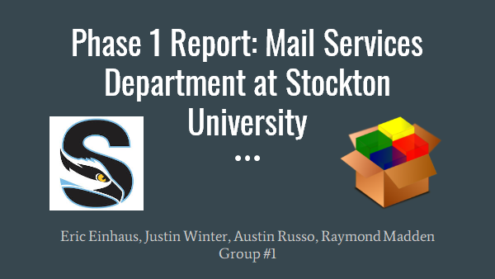

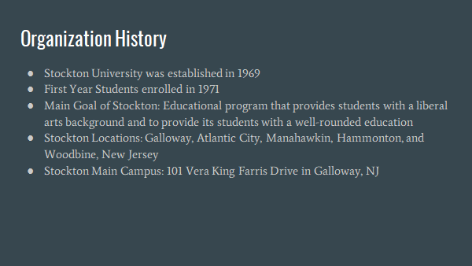

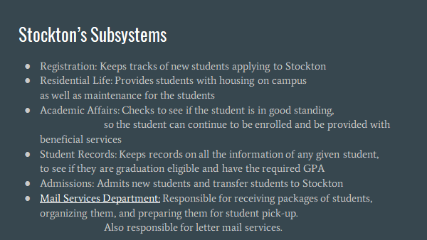

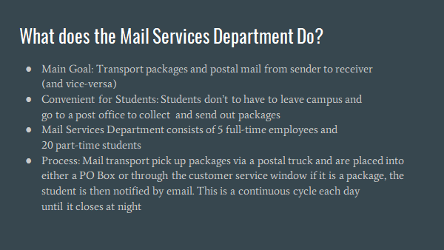

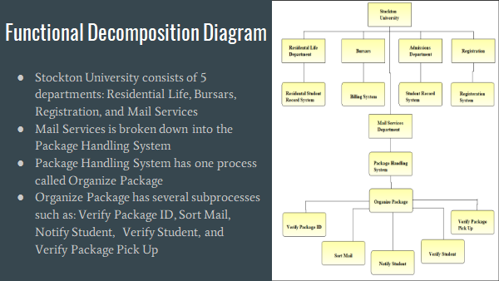

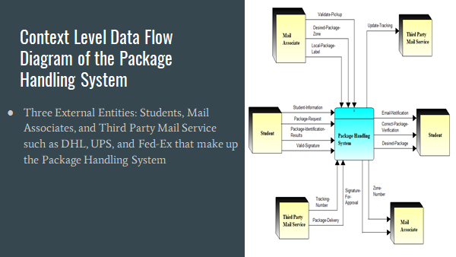

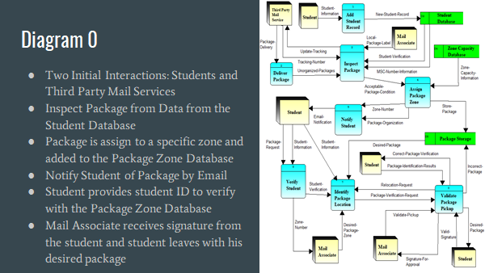

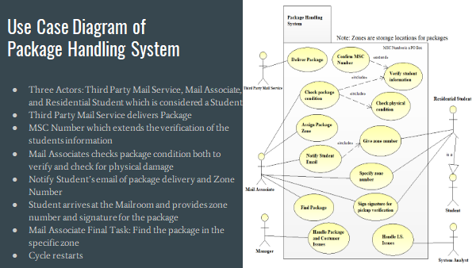

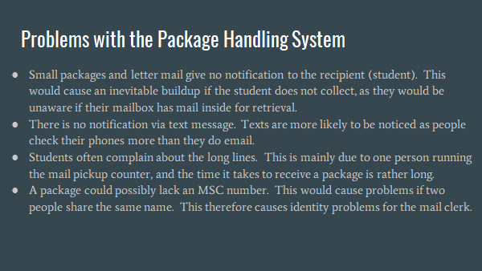

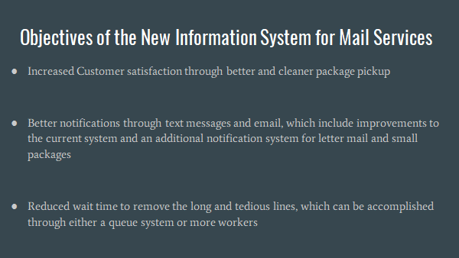

**\*END OF PHASE 1 REPORT\***

**Process Modeling**

The following are:

* Diagram 0 and Description
* 5 Child Diagrams and Descriptions
  + Exploded based on Diagram 0
  + Processes 3, 4, 5, 7, and 8



Above shows the Diagram 0 of the Packaging Handling System. In this diagram, the two initial interactions that needs to be done for the system to process is from the students and from third party mail services. The processes begins with the student and their information, as there information is used to add the student to the database, and their information is then used when the mailroom inspects the package. Before they can inspect a package they first need to receive a package. The third party mail service such as online stores like Amazon, Ebay, USPS, or UPS. The new package is then sent to be inspected, inspecting it with information from the student database. Once the package is deemed acceptable for the mail room, the package is then assigned a zone which is added to the Package Zone Database (storage). The information is then sent to notify the student of a package in the mail room ready to be picked up. The student provides the desired zone and the student ID to find the Desired package. The students information is cross checked with the Package Zone Database to determine if this student is the student the package is for. Once the student is validated to pick up package, the Mail association receives a signature to signify their package was received and then the package is given to the student.

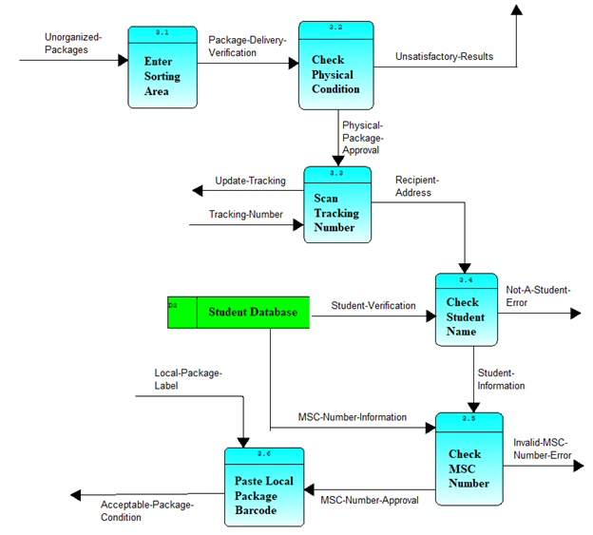

The above image represents the child diagram of process 3, which is known as Inspect Package. To begin the process, unorganized packages are sent to the sorting area, which, if verified, sends out a package delivery verification to the next stage, which is checking the physical condition. If unsuccessful, it releases an unsatisfactory result. If otherwise successful, a physical package approval is sent to the scanner to find its tracking number. The tracking number is entered into the system (this is a required input for the above diagram to work), and if successful, the recipient address is sent to an identifier, which checks for student name, which gets its information from the student database. The student database sends student verification into the process of checking student names to find who the package belongs to. If unsuccessful, an error is outputted, and if not, then student information is sent to help check their MSC number. The MSC number requires the student’s MSC number information from the student database, and if no such number is found, then an error is released. If no error occurs, then the MSC number approval goes to the final part of the process, which pastes a local package barcode onto the package. This part requires a local package label in order to be successful. After this, acceptable package condition(s) is sent off to the next process of diagram 0.

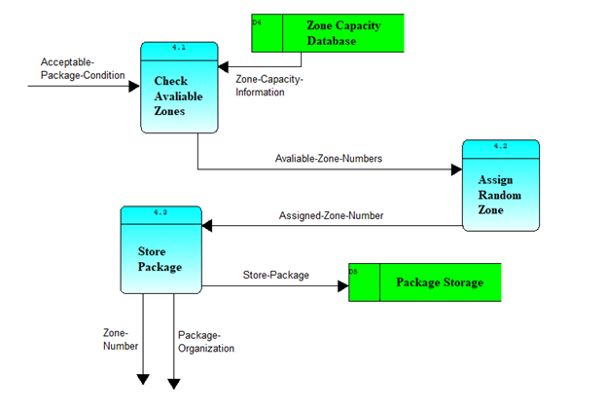

The above picture is a representation of the fourth process on diagram 0, which is known as Assign Package Zone. The process begins with checking for any available zones for a package, which utilizes the zone capacity information from the zone capacity database, along with the acceptable package condition, the latter of which is required for the process to begin. Following this, the available zone numbers are then taken to the next step, which is assigning a random zone to the package. Following this part, the assigned zone number is then utilized on the package, and the package is then sent to be stored in the Package Storage (it is a physical storage unit). Along with that, the process outputs the zone number and the package organization, which are required for other various processes on diagram 0.

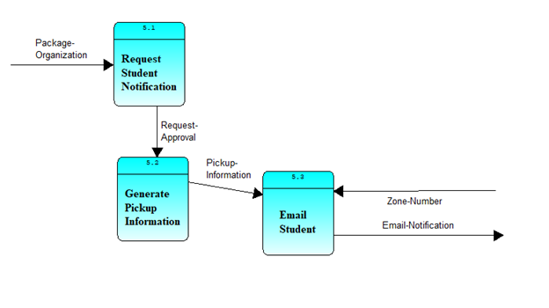

The above image is the child diagram of the fifth process on diagram 0, which is known as Notify Student. To begin, package organization is required as an input. The first part requests a student notification so the recipient can be alerted. If approved, the approval is sent to generate the pickup information. The pickup information is then utilized to email the student (recipient), which requires their zone-number as an input. Once complete, the email notification is sent out to conclude this process on diagram 0.

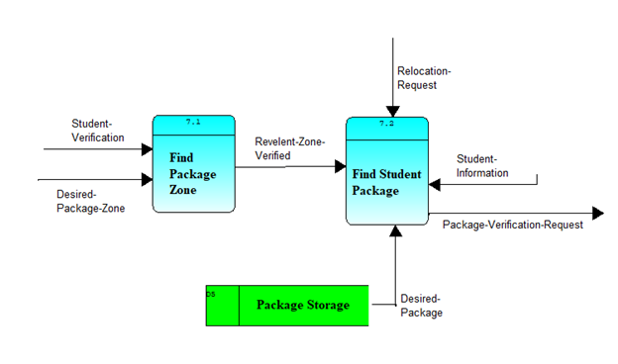

The above image represents the child diagram of the seventh process on diagram 0, which is identifying the package location. To begin, the desired package zone and student verification are required as inputs to the first part of the process. The first part involves finding the package zone of the package being inspected. Once complete, a relevant zone verified alert is sent to the second part, which is finding the student package. To begin, the relocation request and student information are required as inputs, along with the desired package from the package storage. Once complete, the package verification request is sent off to the next process on diagram 0.

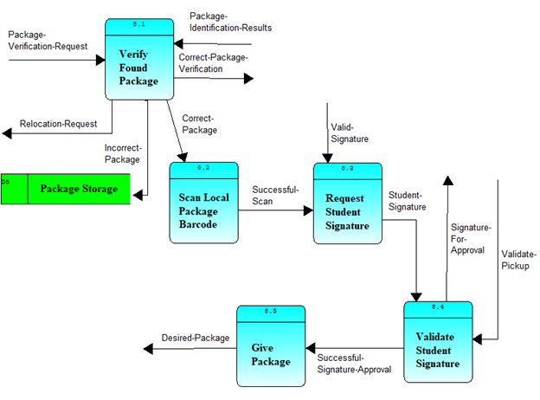

This child diagram is a representation of the steps involved in the eighth process on diagram 0, which is known as validate package pickup. This process begins with the package verification request and package identification results required as inputs to the first part. The first part verifies if the package is the correct one. If the correct one, it shows the package verification was correct, and is outputted to later steps. This also sends the correct package to the next part. If incorrect, the package is put back in the package storage, and a relocation request is sent out instead. In the second part, the barcode of the package is scanned, and if successful, the package continues to the next part, which occurs once the student arrives to claim their package. A signature from the student is required as an input. The student signature is then validated, requiring a proper pickup validation, and once this is complete, the final part occurs. The student is then given their package, and the final output is the desired package. Once complete, process eight officially ends.

**Project Repository**

The following is the Project Repository made on Visible Analyst, including:

1. 3 External Entities
2. 8 Processes on Diagram 0
3. 6 Processes from Child Diagrams

* 3.2, 3.4, 4.1, 7.2, 8.1, 8.4

1. 9 Input Data Flows on the Context Level DFD
   1. Input from Mail Associate
   2. Input from Student
   3. Input from Third Party Mail Service
2. 6 Output Data Flows on the Context Level DFD
   1. Output to Mail Associate
   2. Output to Student
   3. Output to Third Party Mail Service
3. 3 Data Stores

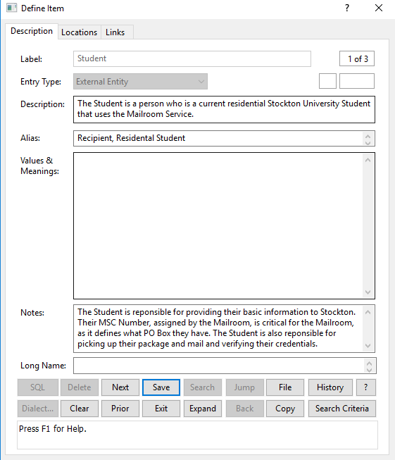

I.

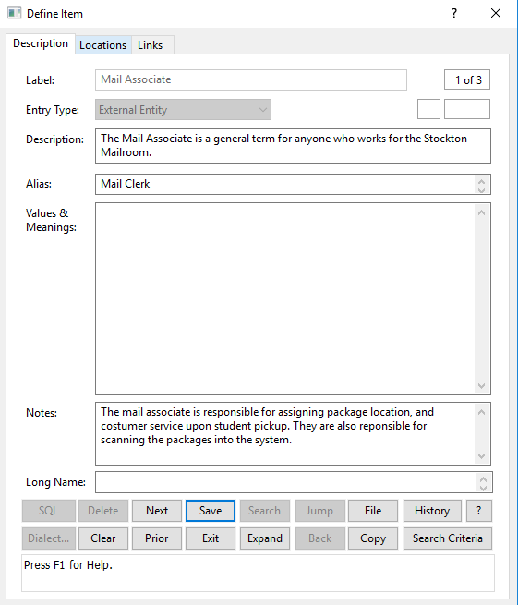

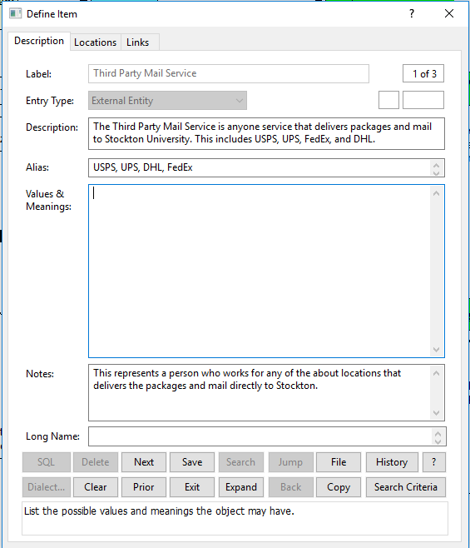

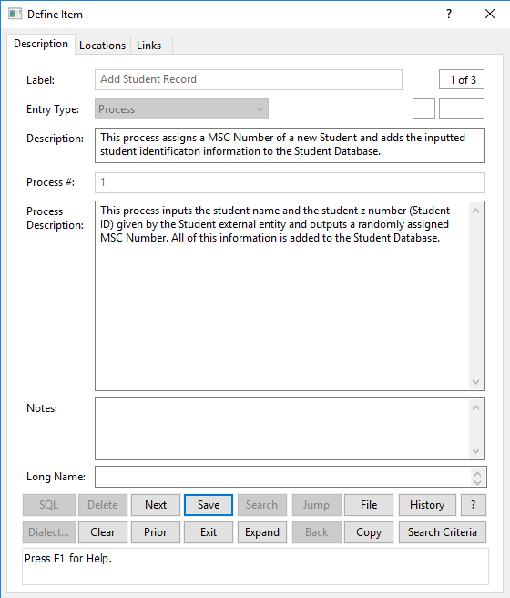

II.

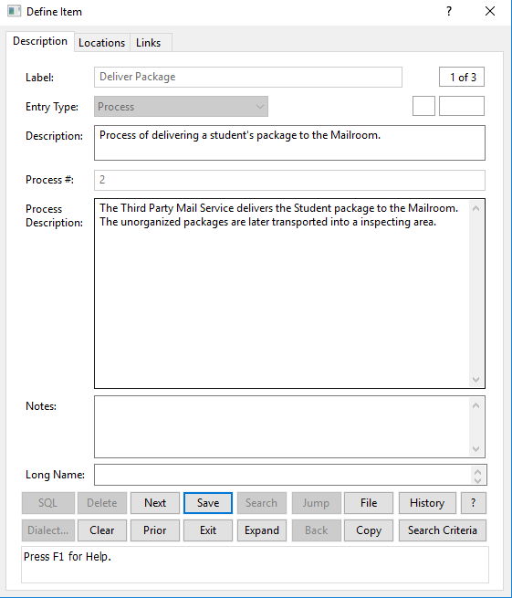

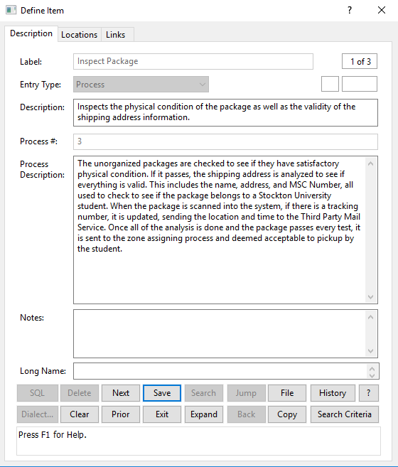

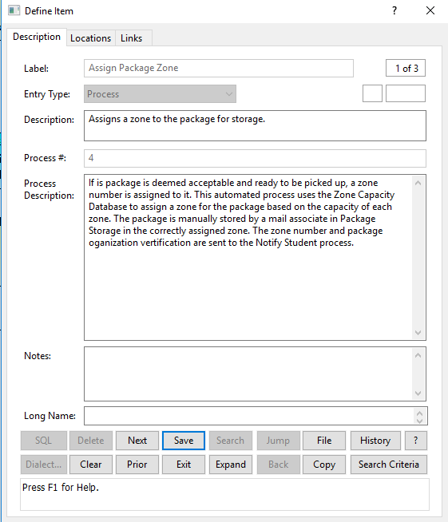

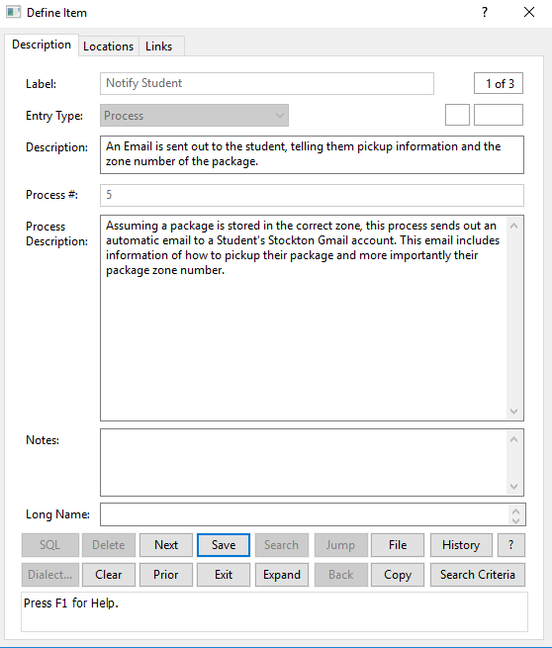

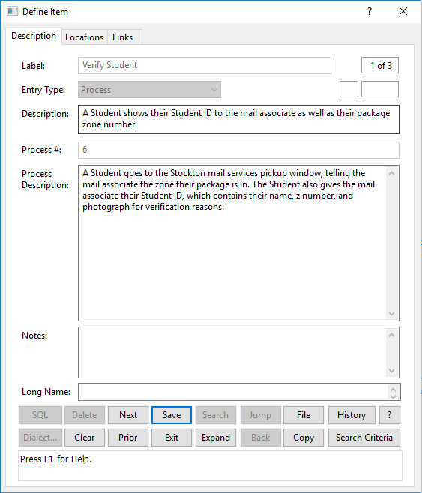

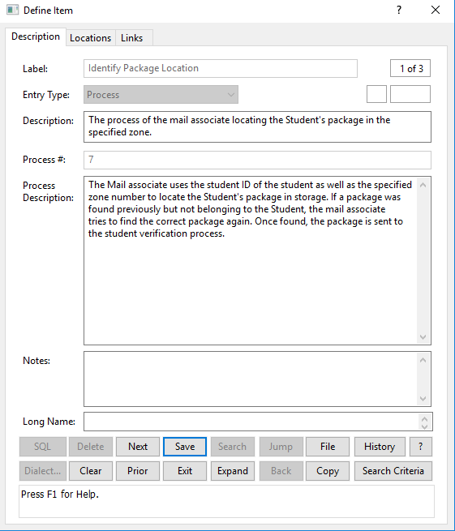

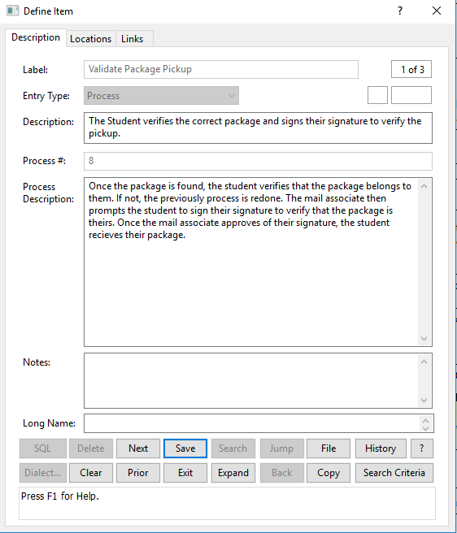

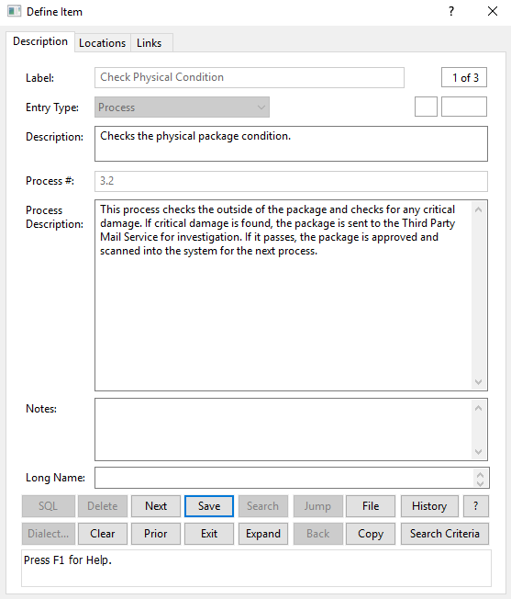

III.

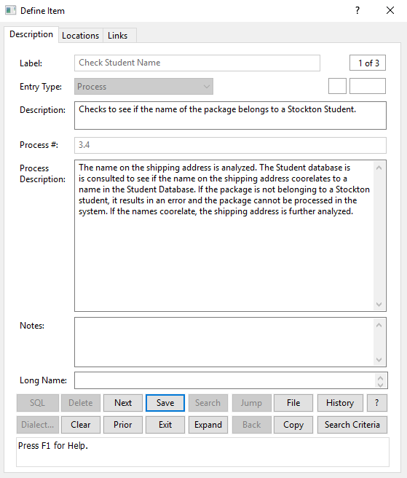

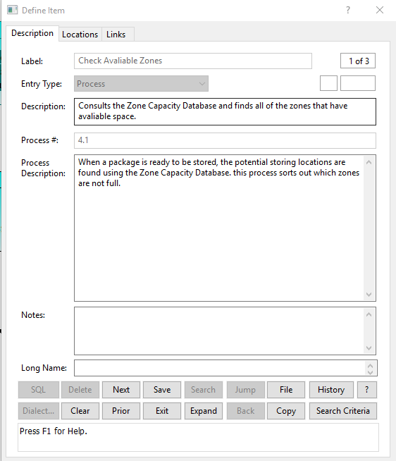

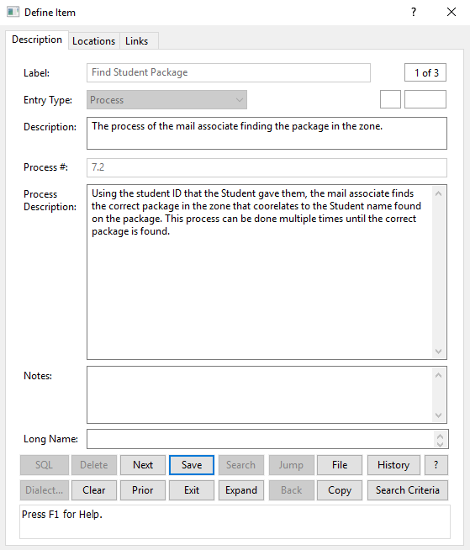

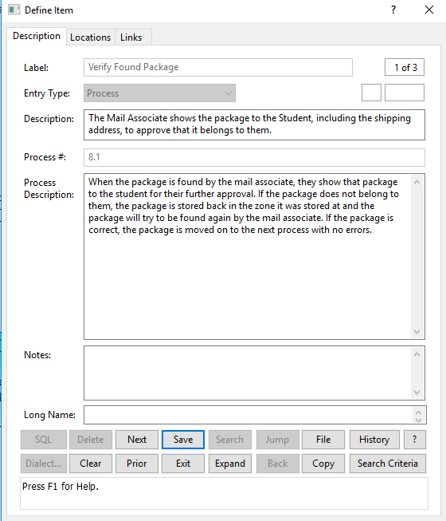

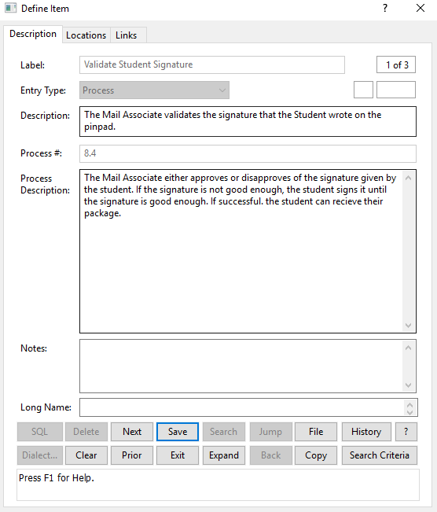

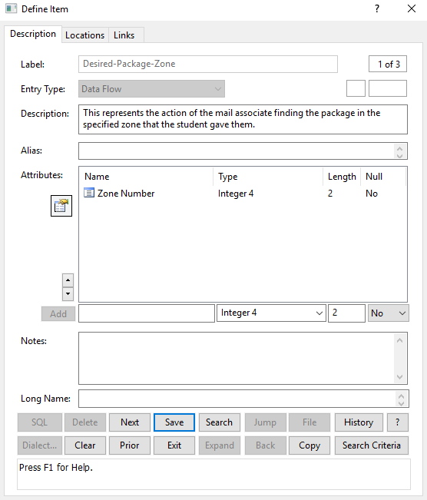

IV. A)

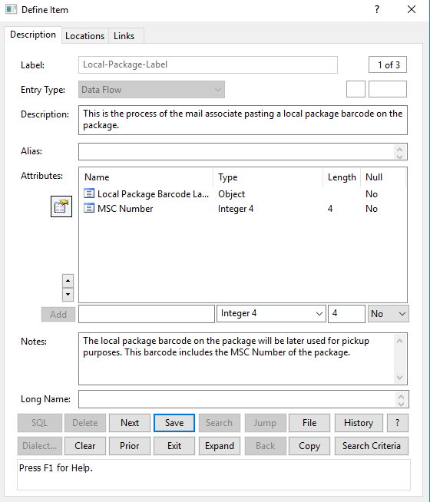

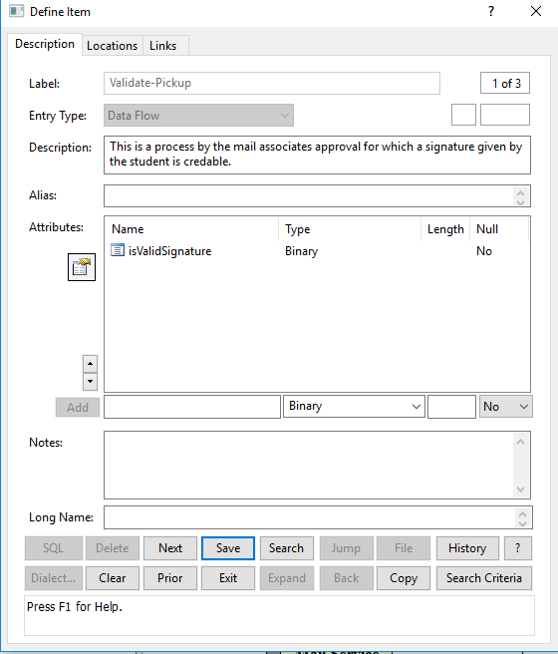

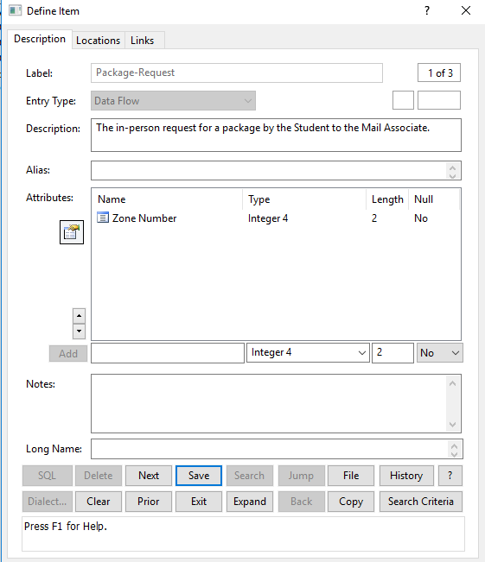

IV. B)

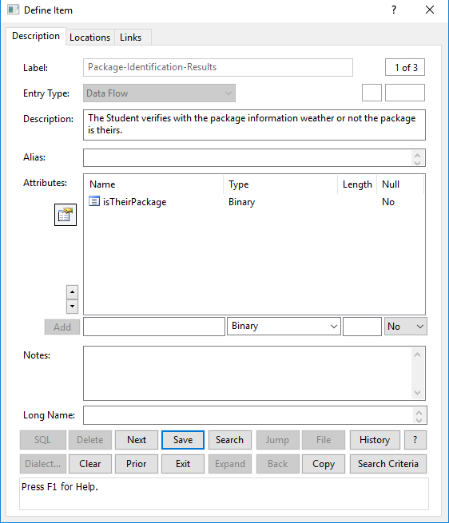

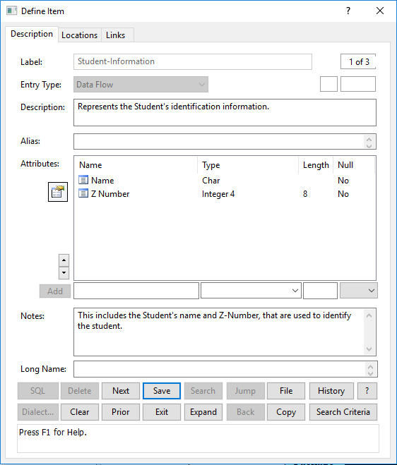

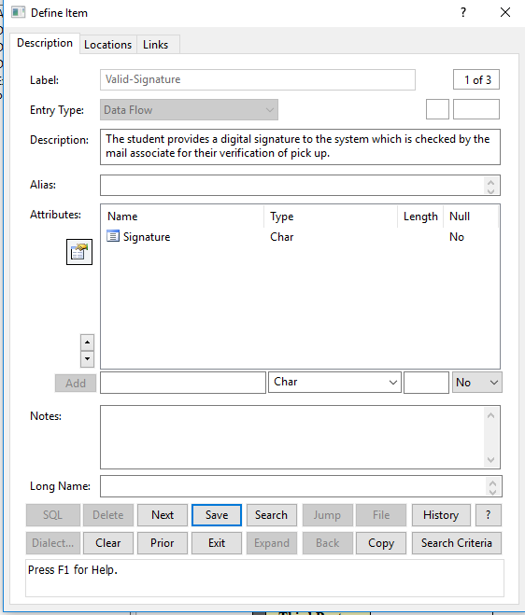

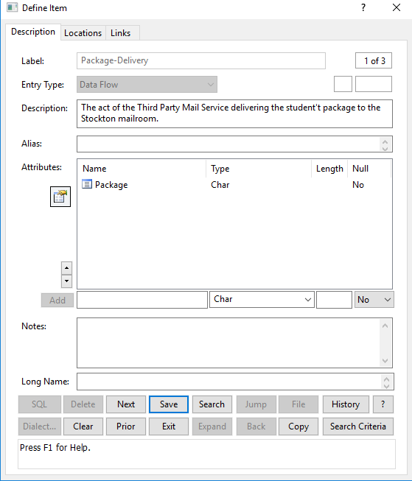

IV. C)

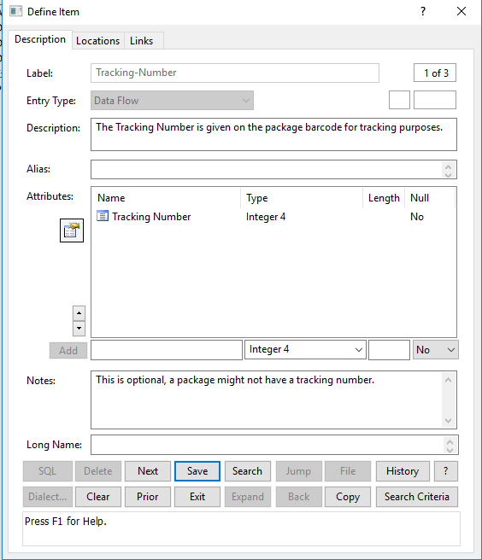

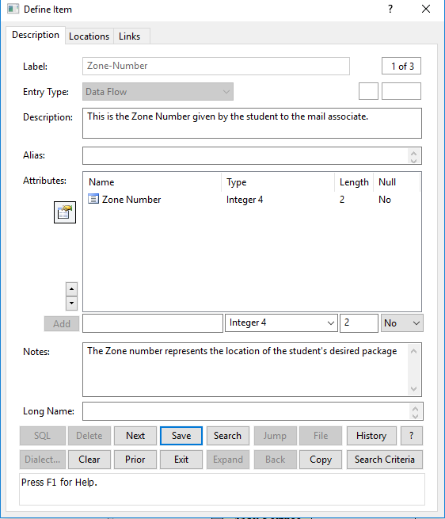

V. A)

V. A)

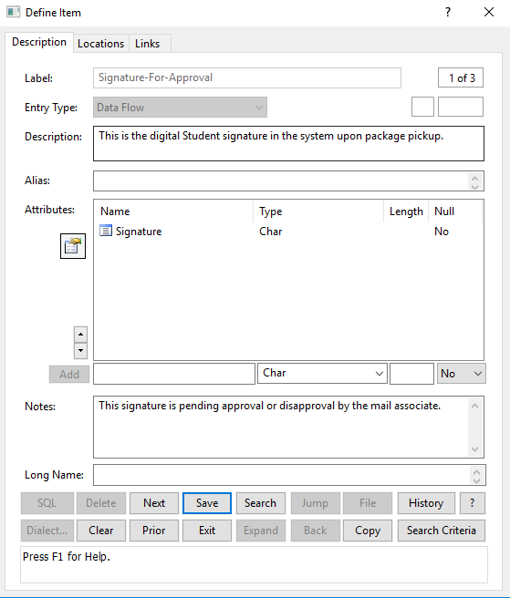

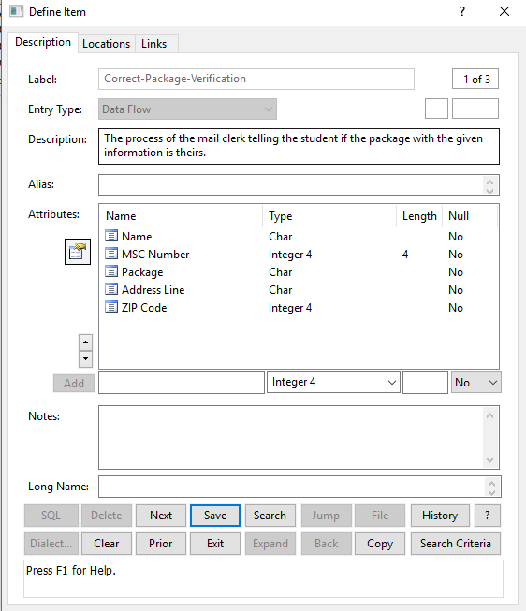

V. B)

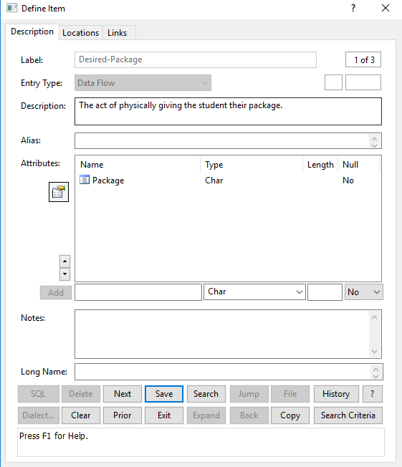

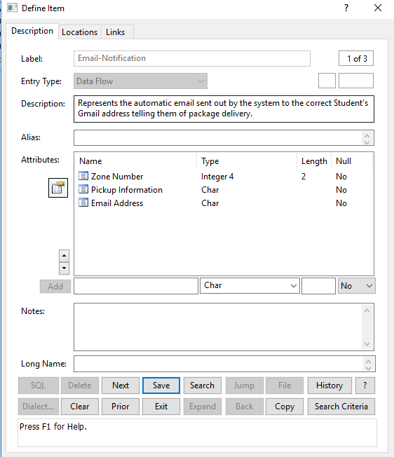

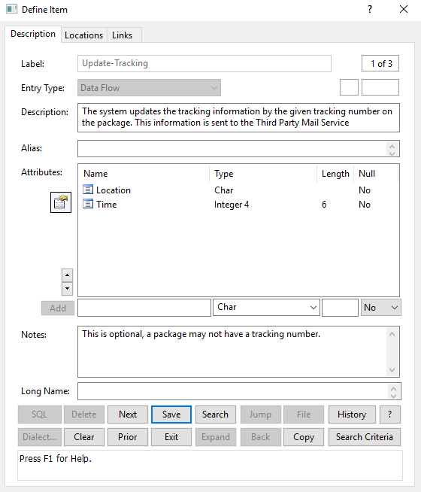

V. C)

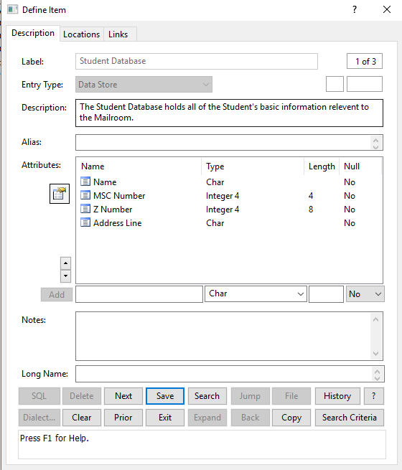

VI.

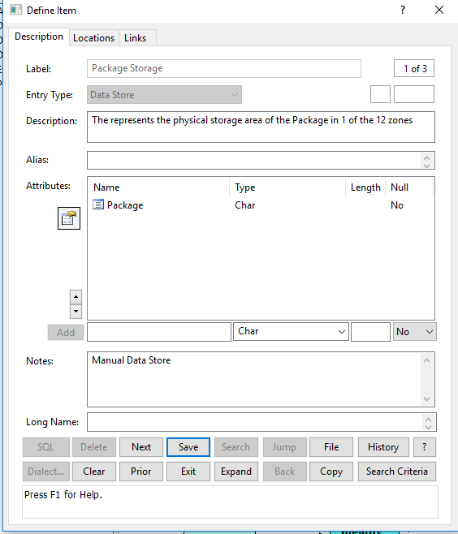

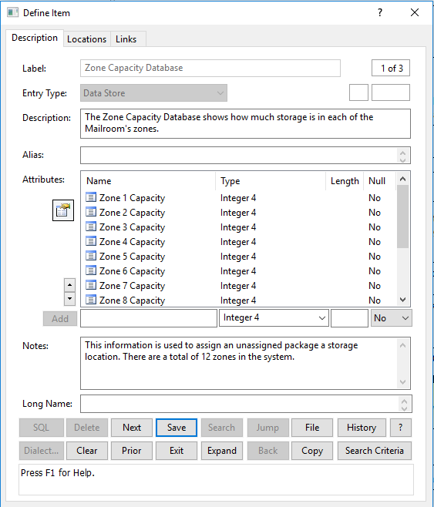

**Process Specification Forms**

The following are the Process Specification forms for Child Processes:

* 3.2 - Check Physical Condition
  + With Decision Tree
* 5.2 - Generate Pickup Information
  + With Decision Tree
* 7.2 - Find Student Package
  + With Structured English
* 8.4 - Validate Student Signature
  + With Decision Table

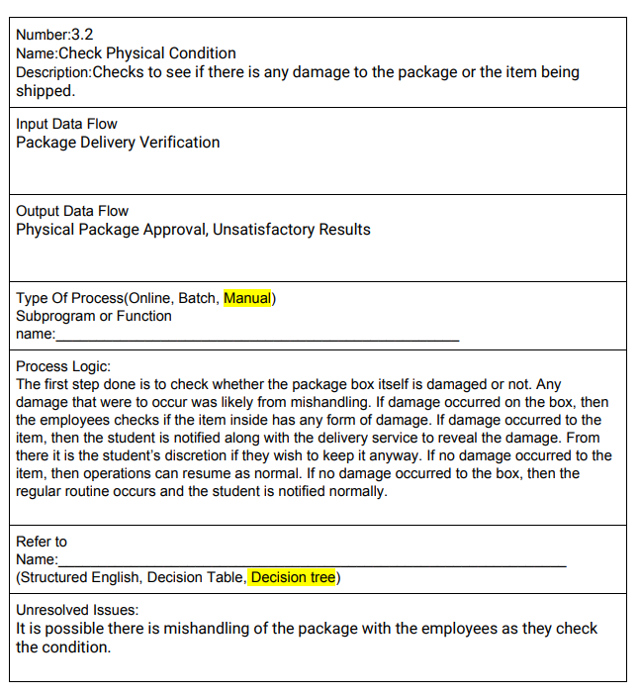

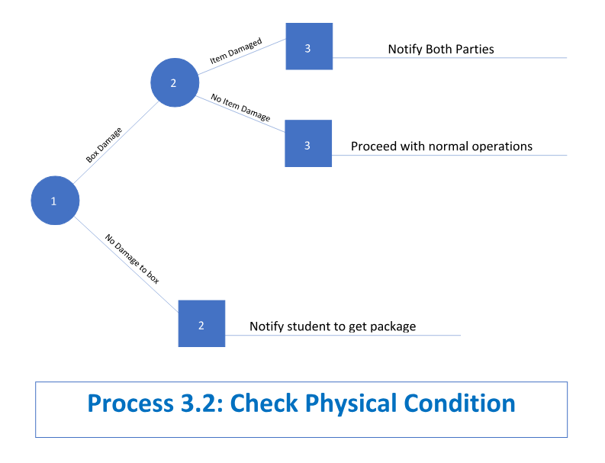

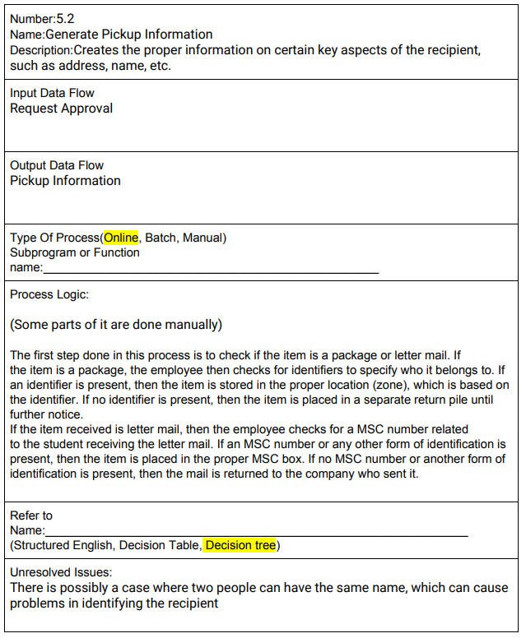

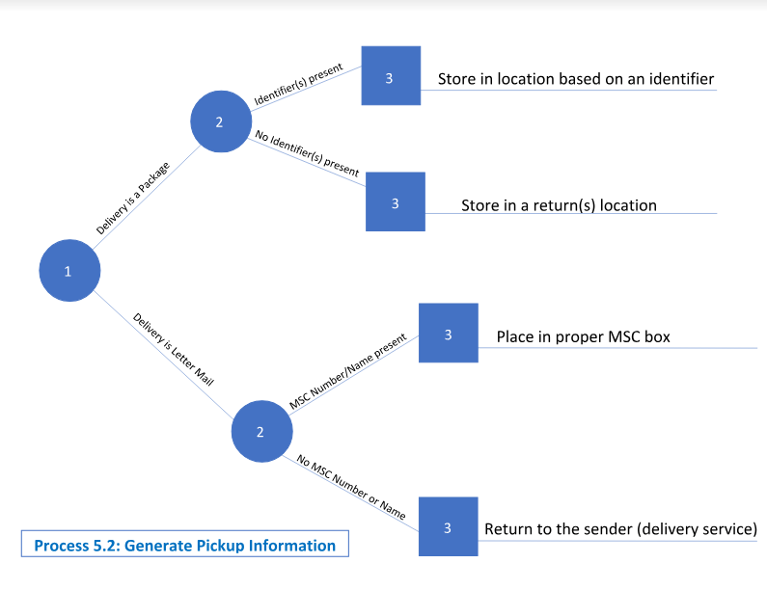

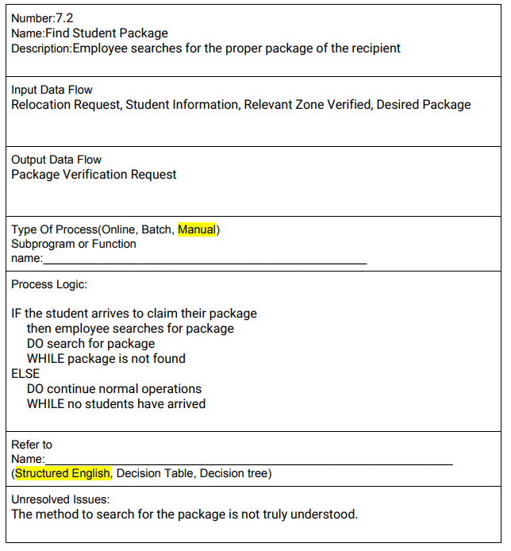

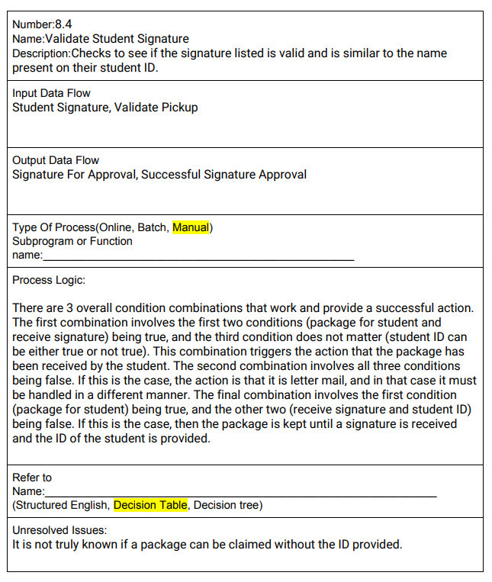

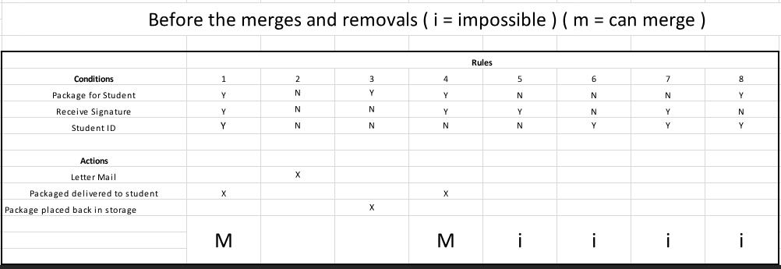

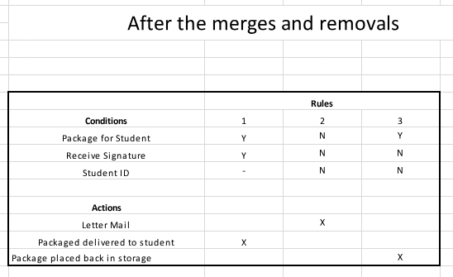

**User Interface**

The following is the proposed user interface for the proposed new information system for the Package Handling System, including:

* goStockton Portal Mailroom Link
* Main Screen
* Student Record screens
* Update Student Record Form
* Text Message Notification
* Update Screens

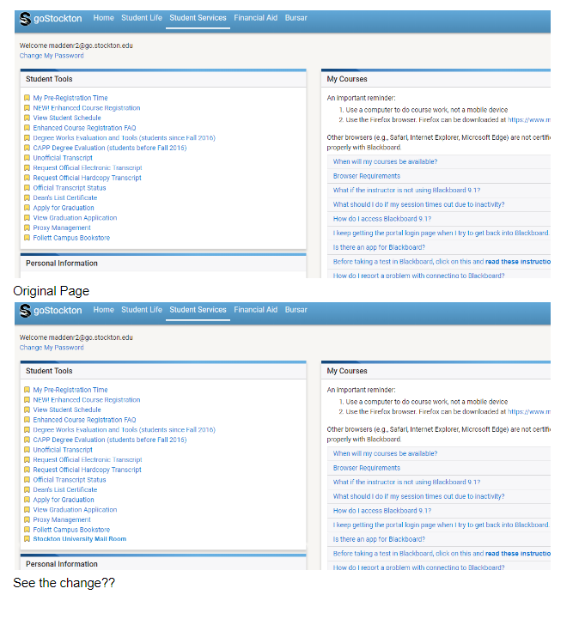

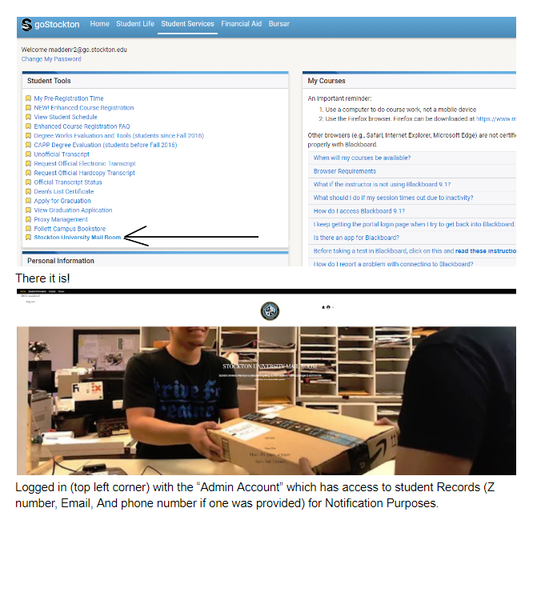

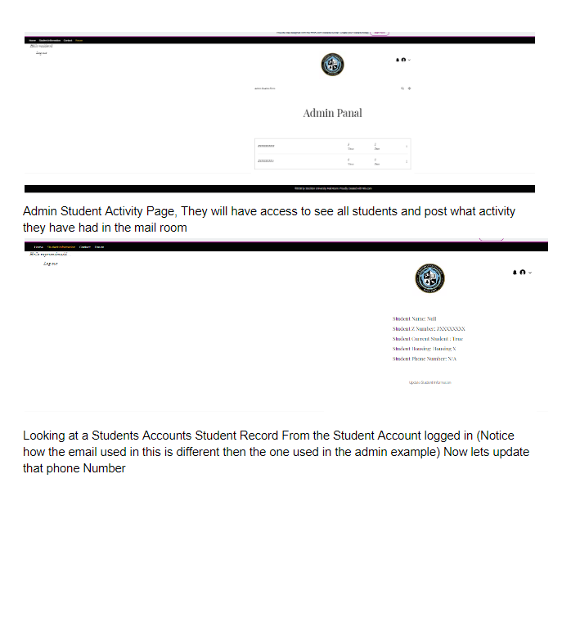

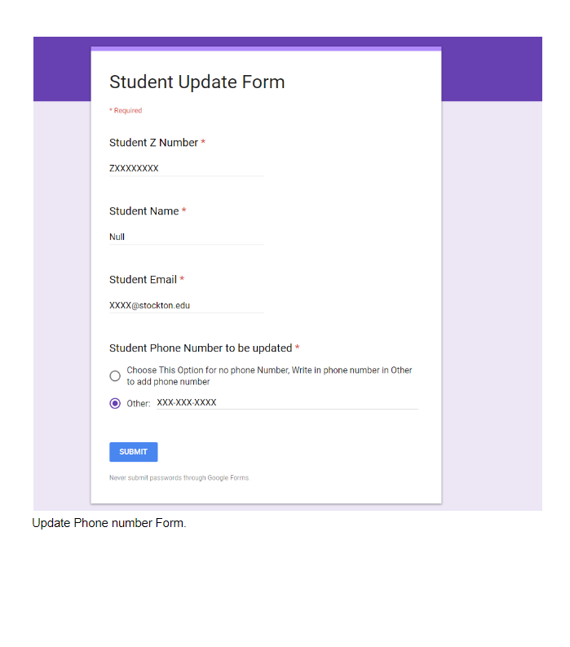

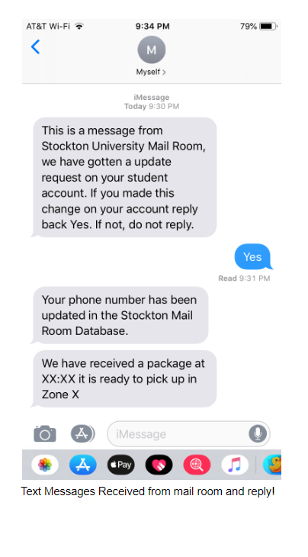

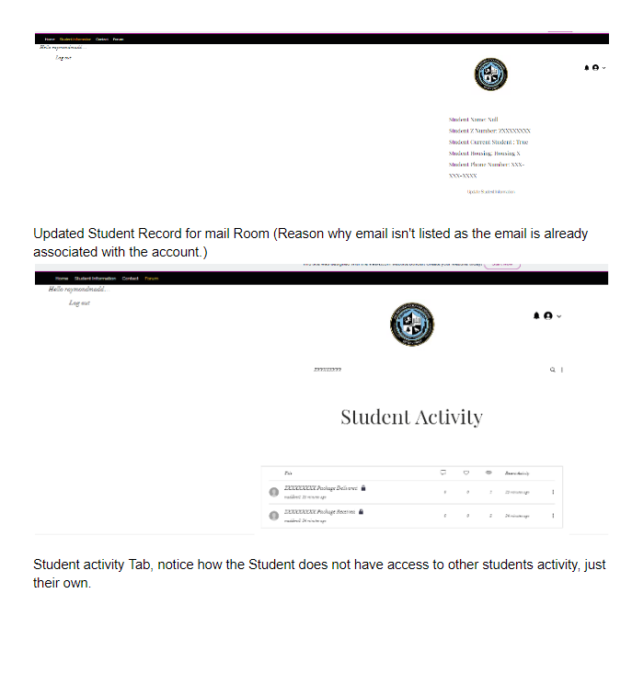

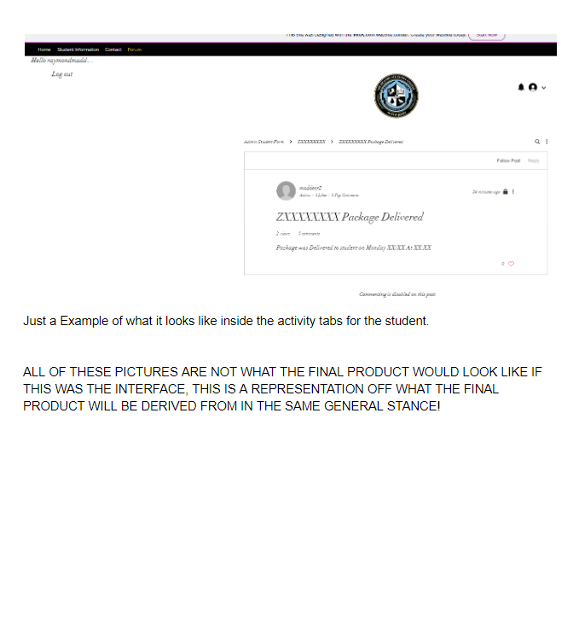

**Visible Analyst Report**

The following is the report of the project, printed from Visible Analyst.

Date: 12/10/2018 Project: MAIL SERVICES DEPARTMENT Page: 1

Time: 11:37:15 AM

Detailed Listing -- Alphabetically

All Entries -- Whole Repository

_________________________________________________________________________________________________

Master Planning Statement Planning Statement

Date Last Altered: 10/31/2018 Date Created: 10/31/2018

---------------------------------------------------------------------------------------------------------------------------------------------

«extend» Relationship

Attached Objects:

Confirm MSC Number

«extend» MIN: ? MAX: many

Verify student information

Foreign Key(s):

Location:

User Case Diagram

Date Last Altered: 11/2/2018 Date Created: 11/2/2018

---------------------------------------------------------------------------------------------------------------------------------------------

«generalize» Data Element

Location:

Relationship Line --> 257

Date Last Altered: 11/2/2018 Date Created: 11/2/2018

---------------------------------------------------------------------------------------------------------------------------------------------

«include» Relationship

Attached Objects:

Check package condition

«include» MIN: ? MAX: many

Verify student information

Foreign Key(s):

Location:

User Case Diagram

Date Last Altered: 11/2/2018 Date Created: 11/2/2018

---------------------------------------------------------------------------------------------------------------------------------------------

Date: 12/10/2018 Project: MAIL SERVICES DEPARTMENT Page: 2

Time: 11:37:15 AM

Detailed Listing -- Alphabetically

All Entries -- Whole Repository

_________________________________________________________________________________________________

«include» Relationship

Attached Objects:

Check package condition

«include» MIN: ? MAX: many

Check physical condition

Foreign Key(s):

Location:

User Case Diagram

Date Last Altered: 11/2/2018 Date Created: 11/2/2018

---------------------------------------------------------------------------------------------------------------------------------------------

«include» Relationship

Attached Objects:

Notify Student Email

«include» MIN: ? MAX: many

Give zone number

Foreign Key(s):

Location:

User Case Diagram

Date Last Altered: 11/2/2018 Date Created: 11/2/2018

---------------------------------------------------------------------------------------------------------------------------------------------

Acceptable-Package-Condition Data Flow

Location:

Diagram 0 ( 0 )

Source: Inspect Package ( Process )

Dest: Assign Package Zone ( Process )

Inspect Package Child ( 3 )

Source: Paste Local Package Barcode ( Process )

Dest: *** Not on Diagram ***

Assign Package Zone Child ( 4 )

Date: 12/10/2018 Project: MAIL SERVICES DEPARTMENT Page: 3

Time: 11:37:15 AM

Detailed Listing -- Alphabetically

All Entries -- Whole Repository

_________________________________________________________________________________________________

Source: *** Not on Diagram ***

Dest: Check Avaliable Zones ( Process )

Date Last Altered: 11/2/2018 Date Created: 11/1/2018

---------------------------------------------------------------------------------------------------------------------------------------------

Add Student Record Process

Description:

This process assigns a MSC Number of a new Student and adds the inputted student identificaton information

to the Student Database.

Process #: 1

Process Description:

This process inputs the student name and the student z number (Student ID) given by the Student external entity and outputs a randomly assigned MSC Number. All of this information is added to the Student Database.

Location:

Diagram 0 ( 0 )

Input Flows:

Student-Information

Output Flows:

New-Student-Record

Date Last Altered: 12/4/2018 Date Created: 11/1/2018

---------------------------------------------------------------------------------------------------------------------------------------------

Address Line Data Element

Data element attributes

Storage Type: Char

Null Type: NotNull

Location:

Data Store --> Student Database

Data Flow --> Correct-Package-Verification

Date Last Altered: 12/4/2018 Date Created: 12/4/2018

---------------------------------------------------------------------------------------------------------------------------------------------

Date: 12/10/2018 Project: MAIL SERVICES DEPARTMENT Page: 4

Time: 11:37:15 AM

Detailed Listing -- Alphabetically

All Entries -- Whole Repository

_________________________________________________________________________________________________

Admissions Department Function

Location:

Stockton FDD

Children: Student Record System ( Process )

Parent: Stockton University ( Function )

Date Last Altered: 10/31/2018 Date Created: 10/31/2018

---------------------------------------------------------------------------------------------------------------------------------------------

are handled by Relationship

Attached Objects:

Packages

are handled by MIN: 1 MAX: many

Employees

[ stores ] MIN: 0 MAX: many

Foreign Key(s):

Packages 'are handled by' Employees

On Delete Restrict

On Update Restrict

On Insert of Child Row Restrict

Location:

Mailroom ER

Date Last Altered: 11/20/2018 Date Created: 11/20/2018

---------------------------------------------------------------------------------------------------------------------------------------------

are handled by Relationship

Attached Objects:

Letter Mail

are handled by MIN: 1 MAX: many

Employees

[ stores ] MIN: 0 MAX: many

Foreign Key(s):

Letter Mail 'are handled by' Employees

On Delete Restrict

On Update Restrict

On Insert of Child Row Restrict

Date: 12/10/2018 Project: MAIL SERVICES DEPARTMENT Page: 5

Time: 11:37:15 AM

Detailed Listing -- Alphabetically

All Entries -- Whole Repository

_________________________________________________________________________________________________

Location:

Mailroom ER

Date Last Altered: 11/20/2018 Date Created: 11/20/2018

---------------------------------------------------------------------------------------------------------------------------------------------

are handled by Relationship

Attached Objects:

Letter Mail

are handled by MIN: 1 MAX: many

Third Party Mail Service

[ delivers ] MIN: 1 MAX: many

Foreign Key(s):

Letter Mail 'are handled by' Third Party Mail Service

On Delete Restrict

On Update Restrict

On Insert of Child Row Restrict

Location:

Mailroom ER

Date Last Altered: 11/20/2018 Date Created: 11/20/2018

---------------------------------------------------------------------------------------------------------------------------------------------

are serviced by Relationship

Attached Objects:

Packages

are serviced by MIN: 1 MAX: many

Third Party Mail Service

[ delivers ] MIN: 1 MAX: many

Foreign Key(s):

Packages 'are serviced by' Third Party Mail Service

On Delete Restrict

On Update Restrict

On Insert of Child Row Restrict

Location:

Mailroom ER

Date: 12/10/2018 Project: MAIL SERVICES DEPARTMENT Page: 6

Time: 11:37:15 AM

Detailed Listing -- Alphabetically

All Entries -- Whole Repository

_________________________________________________________________________________________________

Date Last Altered: 11/20/2018 Date Created: 11/20/2018

---------------------------------------------------------------------------------------------------------------------------------------------

Assign Package Zone Process

Description:

Assigns a zone to the package for storage.

Process #: 4

Process Description:

If is package is deemed acceptable and ready to be picked up, a zone number is assigned to it. This automated process uses the Zone Capacity Database to assign a zone for the package based on the capacity of each zone. The package is manually stored by a

mail associate in Package Storage in the correctly assigned zone. The zone number and package oganization vertification are sent to the Notify Student process.

Location:

Diagram 0 ( 0 )

Input Flows:

Acceptable-Package-Condition

Zone-Capacity-Information

Output Flows:

Package-Organization

Store-Package

Zone-Number

Date Last Altered: 12/4/2018 Date Created: 11/1/2018

---------------------------------------------------------------------------------------------------------------------------------------------

Assign Package Zone Use Case

Location:

User Case Diagram

System Boundary --> Package Handling System

Date Last Altered: 11/2/2018 Date Created: 11/2/2018

---------------------------------------------------------------------------------------------------------------------------------------------

Date: 12/10/2018 Project: MAIL SERVICES DEPARTMENT Page: 7

Time: 11:37:15 AM

Detailed Listing -- Alphabetically

All Entries -- Whole Repository

_________________________________________________________________________________________________

Assign Random Zone Process

Description:

Assigns a random zone for the package.

Process #: 4.2

Process Description:

Assigns a random zone for the package based on the avaliable zone numbers found in the previous process.

Location:

Assign Package Zone Child ( 4 )

Input Flows:

Avaliable-Zone-Numbers

Output Flows:

Assigned-Zone-Number

Date Last Altered: 12/4/2018 Date Created: 11/20/2018

---------------------------------------------------------------------------------------------------------------------------------------------

Assigned-Zone-Number Data Flow

Location:

Assign Package Zone Child ( 4 )

Source: Assign Random Zone ( Process )

Dest: Store Package ( Process )

Date Last Altered: 11/21/2018 Date Created: 11/21/2018

---------------------------------------------------------------------------------------------------------------------------------------------

Avaliable-Zone-Numbers Data Flow

Location:

Assign Package Zone Child ( 4 )

Source: Check Avaliable Zones ( Process )

Dest: Assign Random Zone ( Process )

Date Last Altered: 11/20/2018 Date Created: 11/20/2018

---------------------------------------------------------------------------------------------------------------------------------------------

Date: 12/10/2018 Project: MAIL SERVICES DEPARTMENT Page: 8

Time: 11:37:15 AM

Detailed Listing -- Alphabetically

All Entries -- Whole Repository

_________________________________________________________________________________________________

Billing System Process

Process #: Not Assigned

Location:

Stockton FDD

Parent: Bursars ( Function )

Date Last Altered: 10/31/2018 Date Created: 10/31/2018

---------------------------------------------------------------------------------------------------------------------------------------------

Bursars Function

Location:

Stockton FDD

Children: Billing System ( Process )

Parent: Stockton University ( Function )

Date Last Altered: 10/31/2018 Date Created: 10/31/2018

---------------------------------------------------------------------------------------------------------------------------------------------

Check Avaliable Zones Process

Description:

Consults the Zone Capacity Database and finds all of the zones that have avaliable space.

Process #: 4.1

Process Description:

When a package is ready to be stored, the potential storing locations are found using the Zone Capacity Database. this process sorts out which zones are not full.

Location:

Assign Package Zone Child ( 4 )

Input Flows:

Acceptable-Package-Condition

Zone-Capacity-Information

Output Flows:

Avaliable-Zone-Numbers

Date Last Altered: 12/4/2018 Date Created: 11/20/2018

---------------------------------------------------------------------------------------------------------------------------------------------

Date: 12/10/2018 Project: MAIL SERVICES DEPARTMENT Page: 9

Time: 11:37:15 AM

Detailed Listing -- Alphabetically

All Entries -- Whole Repository

_________________________________________________________________________________________________

Check MSC Number Process

Description:

The MSC Number is checked to see if it is valid and belongs to the Stockton student.

Process #: 3.5

Process Description:

The MSC number on the shipping address is checked to see f it coorelated to a valid MSC Number in the Student database. If the MSC Number is invalid and does not coorelate to the name of the student, this results in an error and the package can not be

processed in the system. If the MSC numbers coorelate, the package can be moved on to the next child process.

Location:

Inspect Package Child ( 3 )

Input Flows:

Student-Information

MSC-Number-Information

Output Flows:

MSC-Number-Approval

Invalid-MSC-Number-Error

Date Last Altered: 12/4/2018 Date Created: 11/20/2018

---------------------------------------------------------------------------------------------------------------------------------------------

Check package condition Use Case

Location:

User Case Diagram

System Boundary --> Package Handling System

All Attached Relationships:

«include» MIN: ? MAX: many

Verify student information

«include» MIN: ? MAX: many

Check physical condition

Date Last Altered: 11/2/2018 Date Created: 11/2/2018

---------------------------------------------------------------------------------------------------------------------------------------------

Date: 12/10/2018 Project: MAIL SERVICES DEPARTMENT Page: 10

Time: 11:37:15 AM

Detailed Listing -- Alphabetically

All Entries -- Whole Repository

_________________________________________________________________________________________________

Check Physical Condition Process

Description:

Checks the physical package condition.

Process #: 3.2

Process Description:

This process checks the outside of the package and checks for any critical damage. If critical damage is found, the package is sent to the Third Party Mail Service for investigation. If it passes, the package is approved and scanned into the system for

the next process.

Location:

Inspect Package Child ( 3 )

Input Flows:

Package-Delivery-Verification

Output Flows:

Physical-Package-Approval

Unsatisfactory-Results

Date Last Altered: 12/4/2018 Date Created: 11/20/2018

---------------------------------------------------------------------------------------------------------------------------------------------

Check physical condition Use Case

Location:

User Case Diagram

System Boundary --> Package Handling System

All Attached Relationships:

[ «include» ] MIN: 1 MAX: 1

Check package condition

Date Last Altered: 11/2/2018 Date Created: 11/2/2018

---------------------------------------------------------------------------------------------------------------------------------------------

Check Student Name Process

Description:

Checks to see if the name of the package belongs to a Stockton Student.

Date: 12/10/2018 Project: MAIL SERVICES DEPARTMENT Page: 11

Time: 11:37:15 AM

Detailed Listing -- Alphabetically

All Entries -- Whole Repository

_________________________________________________________________________________________________

Process #: 3.4

Process Description:

The name on the shipping address is analyzed. The Student database is is consulted to see if the name on the shipping address coorelates to a name in the Student Database. If the package is not belonging to a Stockton student, it results in an error and

the package cannot be processed in the system. If the names coorelate, the shipping address is further analyzed.

Location:

Inspect Package Child ( 3 )

Input Flows:

Recipient-Address

Student-Verification

Output Flows:

Student-Information

Not-A-Student-Error

Date Last Altered: 12/4/2018 Date Created: 11/20/2018

---------------------------------------------------------------------------------------------------------------------------------------------

Confirm MSC Number Use Case

Location:

User Case Diagram

System Boundary --> Package Handling System

All Attached Relationships:

«extend» MIN: ? MAX: many

Verify student information

Date Last Altered: 11/2/2018 Date Created: 11/2/2018

---------------------------------------------------------------------------------------------------------------------------------------------

consists of Relationship

Attached Objects:

Mailroom

consists of MIN: 1 MAX: many

Employees

[ work at ] MIN: 1 MAX: 1

Foreign Key(s):

Mailroom 'consists of' Employees

Date: 12/10/2018 Project: MAIL SERVICES DEPARTMENT Page: 12

Time: 11:37:15 AM

Detailed Listing -- Alphabetically

All Entries -- Whole Repository

_________________________________________________________________________________________________

On Delete Restrict

On Update Restrict

On Insert of Child Row Restrict

Location:

Mailroom ER

Date Last Altered: 11/20/2018 Date Created: 11/20/2018

---------------------------------------------------------------------------------------------------------------------------------------------

Correct-Package Data Flow

Location:

Validate Package Pickup Child ( 8 )

Source: Verify Found Package ( Process )

Dest: Scan Local Package Barcode ( Process )

Date Last Altered: 11/20/2018 Date Created: 11/20/2018

---------------------------------------------------------------------------------------------------------------------------------------------

Correct-Package-Verification Data Flow

Description:

The process of the mail clerk telling the student if the package with the given information is theirs.

Composition:

Name : Char

MSC Number : Integer 4

Package : Char

Address Line : Char

ZIP Code : Integer 4

Location:

Stockton DFD ( CONTEXT )

Source: Package Handling System ( Process )

Dest: Student ( External Entity )

Diagram 0 ( 0 )

Source: Validate Package Pickup ( Process )

Dest: Student ( External Entity )

Date: 12/10/2018 Project: MAIL SERVICES DEPARTMENT Page: 13

Time: 11:37:15 AM

Detailed Listing -- Alphabetically

All Entries -- Whole Repository

_________________________________________________________________________________________________

Validate Package Pickup Child ( 8 )

Source: Verify Found Package ( Process )

Dest: *** Not on Diagram ***

Date Last Altered: 12/4/2018 Date Created: 11/21/2018

---------------------------------------------------------------------------------------------------------------------------------------------

Deliver Package Process

Description:

Process of delivering a student's package to the Mailroom.

Process #: 2

Process Description:

The Third Party Mail Service delivers the Student package to the Mailroom. The unorganized packages are later transported into a inspecting area.

Location:

Diagram 0 ( 0 )

Input Flows:

Package-Delivery

Output Flows:

Unorganized-Packages

Date Last Altered: 12/4/2018 Date Created: 11/1/2018

---------------------------------------------------------------------------------------------------------------------------------------------

Deliver Package Use Case

Location:

User Case Diagram

System Boundary --> Package Handling System

Date Last Altered: 11/2/2018 Date Created: 11/2/2018

---------------------------------------------------------------------------------------------------------------------------------------------

Date: 12/10/2018 Project: MAIL SERVICES DEPARTMENT Page: 14

Time: 11:37:15 AM

Detailed Listing -- Alphabetically

All Entries -- Whole Repository

_________________________________________________________________________________________________

delivers Relationship

Attached Objects:

Third Party Mail Service

delivers MIN: 1 MAX: many

Packages

[ are serviced by ] MIN: 1 MAX: many

Foreign Key(s):

Packages 'are serviced by' Third Party Mail Service

On Delete Restrict

On Update Restrict

On Insert of Child Row Restrict

Location:

Mailroom ER

Date Last Altered: 11/20/2018 Date Created: 11/20/2018

---------------------------------------------------------------------------------------------------------------------------------------------

delivers Relationship

Attached Objects:

Third Party Mail Service

delivers MIN: 1 MAX: many

Letter Mail

[ are handled by ] MIN: 1 MAX: many

Foreign Key(s):

Letter Mail 'are handled by' Third Party Mail Service

On Delete Restrict

On Update Restrict

On Insert of Child Row Restrict

Location:

Mailroom ER

Date Last Altered: 11/20/2018 Date Created: 11/20/2018

---------------------------------------------------------------------------------------------------------------------------------------------

Date: 12/10/2018 Project: MAIL SERVICES DEPARTMENT Page: 15

Time: 11:37:15 AM

Detailed Listing -- Alphabetically

All Entries -- Whole Repository

_________________________________________________________________________________________________

Desired-Package Data Flow

Description:

The act of physically giving the student their package.

Composition:

Package : Char

Location:

Stockton DFD ( CONTEXT )

Source: Package Handling System ( Process )

Dest: Student ( External Entity )

Diagram 0 ( 0 )

Source: Package Storage ( Data Store )

Dest: Identify Package Location ( Process )

Source: Validate Package Pickup ( Process )

Dest: Student ( External Entity )

Identify Package Location Child ( 7 )

Source: Package Storage ( Data Store )

Dest: Find Student Package ( Process )

Validate Package Pickup Child ( 8 )

Source: Give Package ( Process )

Dest: *** Not on Diagram ***

Date Last Altered: 12/4/2018 Date Created: 11/2/2018

---------------------------------------------------------------------------------------------------------------------------------------------

Desired-Package-Zone Data Flow

Description:

This represents the action of the mail associate finding the package in the specified zone that the student gave

them.

Date: 12/10/2018 Project: MAIL SERVICES DEPARTMENT Page: 16

Time: 11:37:15 AM

Detailed Listing -- Alphabetically

All Entries -- Whole Repository

_________________________________________________________________________________________________

Composition:

Zone Number : Integer 4

Location:

Stockton DFD ( CONTEXT )

Source: Mail Associate ( External Entity )

Dest: Package Handling System ( Process )

Diagram 0 ( 0 )

Source: Mail Associate ( External Entity )

Dest: Identify Package Location ( Process )

Identify Package Location Child ( 7 )

Source: *** Not on Diagram ***

Dest: Find Package Zone ( Process )

Date Last Altered: 12/4/2018 Date Created: 11/1/2018

---------------------------------------------------------------------------------------------------------------------------------------------

DNE Process

Process #: 9

Location:

Diagram 0 ( 0 )

Date Last Altered: 11/26/2018 Date Created: 11/20/2018

---------------------------------------------------------------------------------------------------------------------------------------------

Email-Notification Data Flow

Description:

Represents the automatic email sent out by the system to the correct Student's Gmail address telling them of

package delivery.

Composition:

Zone Number : Integer 4

Pickup Information : Char

Email Address : Char

Date: 12/10/2018 Project: MAIL SERVICES DEPARTMENT Page: 17

Time: 11:37:15 AM

Detailed Listing -- Alphabetically

All Entries -- Whole Repository

_________________________________________________________________________________________________

Location:

Stockton DFD ( CONTEXT )

Source: Package Handling System ( Process )

Dest: Student ( External Entity )

Diagram 0 ( 0 )

Source: Notify Student ( Process )

Dest: Student ( External Entity )

Notify Student Child ( 5 )

Source: Email Student ( Process )

Dest: *** Not on Diagram ***

Date Last Altered: 12/4/2018 Date Created: 10/31/2018

---------------------------------------------------------------------------------------------------------------------------------------------

Email Address Data Element

Data element attributes

Storage Type: Char

Null Type: NotNull

Location:

Data Flow --> Email-Notification

Date Last Altered: 12/4/2018 Date Created: 12/4/2018

---------------------------------------------------------------------------------------------------------------------------------------------

Email Student Process

Description:

The email is sent out to the student.

Process #: 5.3

Process Description:

An Email is sent out to the Student's Gmail address, which includes the pickup information and the zone number of the package. This information is crucial for package pickup in later processes.

Date: 12/10/2018 Project: MAIL SERVICES DEPARTMENT Page: 18

Time: 11:37:15 AM

Detailed Listing -- Alphabetically

All Entries -- Whole Repository

_________________________________________________________________________________________________

Location:

Notify Student Child ( 5 )

Input Flows:

Pickup-Information

Zone-Number

Output Flows:

Email-Notification

Date Last Altered: 12/4/2018 Date Created: 11/20/2018

---------------------------------------------------------------------------------------------------------------------------------------------

Employees Entity

Foreign Key(s):

Mailroom 'consists of' Employees

On Delete Restrict

On Update Restrict

On Insert of Child Row Restrict

Packages 'are handled by' Employees

On Delete Restrict

On Update Restrict

On Insert of Child Row Restrict

Letter Mail 'are handled by' Employees

On Delete Restrict

On Update Restrict

On Insert of Child Row Restrict

Location:

Mailroom ER

Attached relationships on Mailroom ER:

work at MIN: 1 MAX: 1

Mailroom

stores MIN: 0 MAX: many

Packages

stores MIN: 0 MAX: many

Letter Mail

Date Last Altered: 11/20/2018 Date Created: 11/20/2018

---------------------------------------------------------------------------------------------------------------------------------------------

Date: 12/10/2018 Project: MAIL SERVICES DEPARTMENT Page: 19

Time: 11:37:15 AM

Detailed Listing -- Alphabetically

All Entries -- Whole Repository

_________________________________________________________________________________________________

Enter Sorting Area Process

Description:

The package is sent to the sorting area of the Mailroom

Process #: 3.1

Process Description:

The package is sent to a package sorting area in the Mailroom to prepare for the physical condition test and the shipping address validity test.

Location:

Inspect Package Child ( 3 )

Input Flows:

Unorganized-Packages

Output Flows:

Package-Delivery-Verification

Date Last Altered: 12/4/2018 Date Created: 11/20/2018

---------------------------------------------------------------------------------------------------------------------------------------------

Find Package Use Case

Location:

User Case Diagram

System Boundary --> Package Handling System

Date Last Altered: 11/2/2018 Date Created: 11/2/2018

---------------------------------------------------------------------------------------------------------------------------------------------

Find Package Zone Process

Description:

The process of the mail associate finding the zone of the desired package.

Process #: 7.1

Process Description:

The Mail Associate uses the Student's specified zone number to find the zone in which the package is located at in Package Storage. Once found, the package can be located.

Date: 12/10/2018 Project: MAIL SERVICES DEPARTMENT Page: 20

Time: 11:37:15 AM

Detailed Listing -- Alphabetically

All Entries -- Whole Repository

_________________________________________________________________________________________________

Location:

Identify Package Location Child ( 7 )

Input Flows:

Student-Verification

Desired-Package-Zone

Output Flows:

Revelent-Zone-Verified

Date Last Altered: 12/4/2018 Date Created: 11/20/2018

---------------------------------------------------------------------------------------------------------------------------------------------

Find Student Package Process

Description:

The process of the mail associate finding the package in the zone.

Process #: 7.2

Process Description:

Using the student ID that the Student gave them, the mail associate finds the correct package in the zone that coorelates to the Student name found on the package. This process can be done multiple times until the correct package is found.

Location:

Identify Package Location Child ( 7 )

Input Flows:

Revelent-Zone-Verified

Student-Information

Desired-Package

Relocation-Request

Output Flows:

Package-Verification-Request

Date Last Altered: 12/4/2018 Date Created: 11/20/2018

---------------------------------------------------------------------------------------------------------------------------------------------

Generate Pickup Information Process

Description:

Pickup information is generated by the system.

Process #: 5.2

Date: 12/10/2018 Project: MAIL SERVICES DEPARTMENT Page: 21

Time: 11:37:15 AM

Detailed Listing -- Alphabetically

All Entries -- Whole Repository

_________________________________________________________________________________________________

Process Description:

Pickup information is generated by the system, which includes information on how to get to the mailroom and what to bring to the mailroom upon arrival. This information will be automatically inputted onto the email as a template.

Location:

Notify Student Child ( 5 )

Input Flows:

Request-Approval

Output Flows:

Pickup-Information

Date Last Altered: 12/4/2018 Date Created: 11/20/2018

---------------------------------------------------------------------------------------------------------------------------------------------

Give Package Process

Description:

The Mail Associate gives the package to the Student.

Process #: 8.5

Process Description:

Once the signature is validated, the student can recieve their package.

Location:

Validate Package Pickup Child ( 8 )

Input Flows:

Successful-Signature-Approval

Output Flows:

Desired-Package

Date Last Altered: 12/4/2018 Date Created: 11/20/2018

---------------------------------------------------------------------------------------------------------------------------------------------

Give zone number Use Case

Location:

User Case Diagram

System Boundary --> Package Handling System

Date: 12/10/2018 Project: MAIL SERVICES DEPARTMENT Page: 22

Time: 11:37:15 AM

Detailed Listing -- Alphabetically

All Entries -- Whole Repository

_________________________________________________________________________________________________

All Attached Relationships:

[ «include» ] MIN: 1 MAX: 1

Notify Student Email

Date Last Altered: 11/2/2018 Date Created: 11/2/2018

---------------------------------------------------------------------------------------------------------------------------------------------

go to Relationship

Attached Objects:

Students

go to MIN: 1 MAX: 1

Mailroom

[ services ] MIN: 1 MAX: many

Foreign Key(s):

Mailroom 'services' Students

On Delete Restrict

On Update Restrict

On Insert of Child Row Restrict

Location:

Mailroom ER

Date Last Altered: 11/20/2018 Date Created: 11/20/2018

---------------------------------------------------------------------------------------------------------------------------------------------

Handle I.S. Issues Use Case

Location:

User Case Diagram

System Boundary --> Package Handling System

Date Last Altered: 11/6/2018 Date Created: 11/6/2018

---------------------------------------------------------------------------------------------------------------------------------------------

Handle Package and Costumer Issues Use Case

Location:

User Case Diagram

Date: 12/10/2018 Project: MAIL SERVICES DEPARTMENT Page: 23

Time: 11:37:15 AM

Detailed Listing -- Alphabetically

All Entries -- Whole Repository

_________________________________________________________________________________________________

System Boundary --> Package Handling System

Date Last Altered: 11/6/2018 Date Created: 11/6/2018

---------------------------------------------------------------------------------------------------------------------------------------------

Identify Package Location Process

Description:

The process of the mail associate locating the Student's package in the specified zone.

Process #: 7

Process Description:

The Mail associate uses the student ID of the student as well as the specified zone number to locate the Student's package in storage. If a package was found previously but not belonging to the Student, the mail associate tries to find the correct

package again. Once found, the package is sent to the student verification process.

Location:

Diagram 0 ( 0 )

Input Flows:

Student-Verification

Desired-Package-Zone

Desired-Package

Relocation-Request

Student-Information

Output Flows:

Package-Verification-Request

Date Last Altered: 12/4/2018 Date Created: 11/1/2018

---------------------------------------------------------------------------------------------------------------------------------------------

Incorrect-Package Data Flow

Location:

Diagram 0 ( 0 )

Source: Validate Package Pickup ( Process )

Dest: Package Storage ( Data Store )

Validate Package Pickup Child ( 8 )

Source: Verify Found Package ( Process )

Dest: Package Storage ( Data Store )

Date: 12/10/2018 Project: MAIL SERVICES DEPARTMENT Page: 24

Time: 11:37:15 AM

Detailed Listing -- Alphabetically

All Entries -- Whole Repository

_________________________________________________________________________________________________

Date Last Altered: 11/20/2018 Date Created: 11/20/2018

---------------------------------------------------------------------------------------------------------------------------------------------

Inspect Package Process

Description:

Inspects the physical condition of the package as well as the validity of the shipping address information.

Process #: 3

Process Description:

The unorganized packages are checked to see if they have satisfactory physical condition. If it passes, the shipping address is analyzed to see if everything is valid. This includes the name, address, and MSC Number, all used to check to see if the packa

ge belongs to a Stockton University student. When the package is scanned into the system, if there is a tracking number, it is updated, sending the location and time to the Third Party Mail Service. Once all of the analysis is done and the package passes

every test, it is sent to the zone assigning process and deemed acceptable to pickup by the student.

Location:

Diagram 0 ( 0 )

Input Flows:

Student-Verification

MSC-Number-Information

Unorganized-Packages

Local-Package-Label

Tracking-Number

Output Flows:

Acceptable-Package-Condition

Update-Tracking

Date Last Altered: 12/4/2018 Date Created: 11/1/2018

---------------------------------------------------------------------------------------------------------------------------------------------

Invalid-MSC-Number-Error Data Flow

Location:

Inspect Package Child ( 3 )

Source: Check MSC Number ( Process )

Dest: *** Not on Diagram ***

Date Last Altered: 11/20/2018 Date Created: 11/20/2018

---------------------------------------------------------------------------------------------------------------------------------------------

Date: 12/10/2018 Project: MAIL SERVICES DEPARTMENT Page: 25

Time: 11:37:15 AM

Detailed Listing -- Alphabetically

All Entries -- Whole Repository

_________________________________________________________________________________________________

is a Relationship

Attached Objects:

Residential Student

is a MIN: 0 MAX: 1

Student

Foreign Key(s):

Location:

User Case Diagram

Date Last Altered: 11/2/2018 Date Created: 11/2/2018

---------------------------------------------------------------------------------------------------------------------------------------------

is a Relationship

Attached Objects:

Student

is a MIN: 0 MAX: 1

Student

Foreign Key(s):

Date Last Altered: 11/2/2018 Date Created: 11/2/2018

---------------------------------------------------------------------------------------------------------------------------------------------

isTheirPackage Data Element

Data element attributes

Storage Type: Binary

Null Type: NotNull

Location:

Data Flow --> Package-Identification-Results

Date Last Altered: 12/4/2018 Date Created: 12/4/2018

---------------------------------------------------------------------------------------------------------------------------------------------

isValidSignature Data Element

Data element attributes

Storage Type: Binary

Null Type: NotNull

Date: 12/10/2018 Project: MAIL SERVICES DEPARTMENT Page: 26

Time: 11:37:15 AM

Detailed Listing -- Alphabetically

All Entries -- Whole Repository

_________________________________________________________________________________________________

Location:

Data Flow --> Validate-Pickup

Date Last Altered: 12/4/2018 Date Created: 12/4/2018

---------------------------------------------------------------------------------------------------------------------------------------------

Letter Mail Associative Entity

Location:

Mailroom ER

Attached relationships on Mailroom ER:

are handled by MIN: 1 MAX: many

Employees

are handled by MIN: 1 MAX: many

Third Party Mail Service

Date Last Altered: 11/20/2018 Date Created: 11/20/2018

---------------------------------------------------------------------------------------------------------------------------------------------

Local-Package-Label Data Flow

Description:

This is the process of the mail associate pasting a local package barcode on the package.

Composition:

Local Package Barcode Label : Object

MSC Number : Integer 4

Notes:

The local package barcode on the package will be later used for pickup purposes. This barcode includes the

MSC Number of the package.

Location:

Stockton DFD ( CONTEXT )

Source: Mail Associate ( External Entity )

Dest: Package Handling System ( Process )

Diagram 0 ( 0 )

Date: 12/10/2018 Project: MAIL SERVICES DEPARTMENT Page: 27

Time: 11:37:15 AM

Detailed Listing -- Alphabetically

All Entries -- Whole Repository

_________________________________________________________________________________________________

Source: Mail Associate ( External Entity )

Dest: Inspect Package ( Process )

Inspect Package Child ( 3 )

Source: *** Not on Diagram ***

Dest: Paste Local Package Barcode ( Process )

Date Last Altered: 12/4/2018 Date Created: 11/20/2018

---------------------------------------------------------------------------------------------------------------------------------------------

Local Package Barcode Label Data Element

Data element attributes

Domain: Object

Storage Type: Undefined

Location:

Data Flow --> Local-Package-Label

Date Last Altered: 12/4/2018 Date Created: 12/4/2018

---------------------------------------------------------------------------------------------------------------------------------------------

Location Data Element

Data element attributes

Storage Type: Char

Null Type: NotNull

Location:

Data Flow --> Update-Tracking

Date Last Altered: 12/4/2018 Date Created: 12/4/2018

---------------------------------------------------------------------------------------------------------------------------------------------

Mail Associate External Entity

Description:

The Mail Associate is a general term for anyone who works for the Stockton Mailroom.

Alias:

Mail Clerk

Date: 12/10/2018 Project: MAIL SERVICES DEPARTMENT Page: 28

Time: 11:37:15 AM

Detailed Listing -- Alphabetically

All Entries -- Whole Repository

_________________________________________________________________________________________________

Notes:

The mail associate is responsible for assigning package location, and costumer service upon student pickup.

They are also reponsible for scanning the packages into the system.

Location:

Stockton DFD ( CONTEXT )

Input Flows:

Zone-Number

Signature-For-Approval

Output Flows:

Local-Package-Label

Desired-Package-Zone

Validate-Pickup

Diagram 0 ( 0 )

Input Flows:

Zone-Number

Output Flows:

Desired-Package-Zone

Input Flows:

Signature-For-Approval

Output Flows:

Validate-Pickup

Output Flows:

Local-Package-Label

Date Last Altered: 12/4/2018 Date Created: 10/31/2018

---------------------------------------------------------------------------------------------------------------------------------------------

Mail Associate Actor

Location:

User Case Diagram

Date Last Altered: 11/2/2018 Date Created: 11/2/2018

---------------------------------------------------------------------------------------------------------------------------------------------

Date: 12/10/2018 Project: MAIL SERVICES DEPARTMENT Page: 29

Time: 11:37:15 AM

Detailed Listing -- Alphabetically

All Entries -- Whole Repository

_________________________________________________________________________________________________

Mail Clerk Alias

Alias:

Mail Associate

Date Last Altered: 12/4/2018 Date Created: 12/4/2018

---------------------------------------------------------------------------------------------------------------------------------------------

Mail Services Department Function

Location:

Stockton FDD

Children: Package Handling System ( Process )

Parent: Stockton University ( Function )

Date Last Altered: 10/31/2018 Date Created: 10/31/2018

---------------------------------------------------------------------------------------------------------------------------------------------

Mailroom Associative Entity

Location:

Mailroom ER

Attached relationships on Mailroom ER:

services MIN: 1 MAX: many

Students

consists of MIN: 1 MAX: many

Employees

Date Last Altered: 11/20/2018 Date Created: 11/20/2018

---------------------------------------------------------------------------------------------------------------------------------------------

Manager Actor

Location:

User Case Diagram

Date Last Altered: 11/6/2018 Date Created: 11/6/2018

---------------------------------------------------------------------------------------------------------------------------------------------

Date: 12/10/2018 Project: MAIL SERVICES DEPARTMENT Page: 30

Time: 11:37:15 AM

Detailed Listing -- Alphabetically

All Entries -- Whole Repository

_________________________________________________________________________________________________

MSC-Number-Approval Data Flow

Location:

Inspect Package Child ( 3 )

Source: Check MSC Number ( Process )

Dest: Paste Local Package Barcode ( Process )

Date Last Altered: 11/20/2018 Date Created: 11/20/2018

---------------------------------------------------------------------------------------------------------------------------------------------

MSC-Number-Information Data Flow

Location:

Diagram 0 ( 0 )

Source: Student Database ( Data Store )

Dest: Inspect Package ( Process )

Inspect Package Child ( 3 )

Source: Student Database ( Data Store )

Dest: Check MSC Number ( Process )

Date Last Altered: 10/31/2018 Date Created: 10/31/2018

---------------------------------------------------------------------------------------------------------------------------------------------

MSC Number Data Element

Data element attributes

Storage Type: Integer 4

Length: 4

Null Type: NotNull

Location:

Data Store --> Student Database

Data Flow --> New-Student-Record

Data Flow --> Local-Package-Label

Data Flow --> Correct-Package-Verification

Date Last Altered: 12/4/2018 Date Created: 12/4/2018

---------------------------------------------------------------------------------------------------------------------------------------------

Date: 12/10/2018 Project: MAIL SERVICES DEPARTMENT Page: 31

Time: 11:37:15 AM

Detailed Listing -- Alphabetically

All Entries -- Whole Repository

_________________________________________________________________________________________________

Name Data Element

Data element attributes

Storage Type: Char

Null Type: NotNull

Location:

Data Store --> Student Database

Data Flow --> New-Student-Record

Data Flow --> Student-Information

Data Flow --> Correct-Package-Verification

Date Last Altered: 12/4/2018 Date Created: 12/4/2018

---------------------------------------------------------------------------------------------------------------------------------------------

New-Student-Record Data Flow

Description:

A process that includes the Student's identification information and a new MSC Number generated from

process 1.

Composition:

Name : Char

Z Number : Integer 4

MSC Number : Integer 4

Location:

Diagram 0 ( 0 )

Source: Add Student Record ( Process )

Dest: Student Database ( Data Store )

Date Last Altered: 12/4/2018 Date Created: 11/1/2018

---------------------------------------------------------------------------------------------------------------------------------------------

Not-A-Student-Error Data Flow

Location:

Inspect Package Child ( 3 )

Source: Check Student Name ( Process )

Dest: *** Not on Diagram ***

Date: 12/10/2018 Project: MAIL SERVICES DEPARTMENT Page: 32

Time: 11:37:15 AM

Detailed Listing -- Alphabetically

All Entries -- Whole Repository

_________________________________________________________________________________________________

Date Last Altered: 11/20/2018 Date Created: 11/20/2018

---------------------------------------------------------------------------------------------------------------------------------------------

Notify Student Process

Description:

An Email is sent out to the student, telling them pickup information and the zone number of the package.

Process #: 5

Process Description:

Assuming a package is stored in the correct zone, this process sends out an automatic email to a Student's Stockton Gmail account. This email includes information of how to pickup their package and more importantly their package zone number.

Location:

Diagram 0 ( 0 )

Input Flows:

Package-Organization

Zone-Number

Output Flows:

Email-Notification

Stockton FDD

Parent: Organize Package ( Process )

Date Last Altered: 12/4/2018 Date Created: 10/31/2018

---------------------------------------------------------------------------------------------------------------------------------------------

Notify Student Email Use Case

Location:

User Case Diagram

System Boundary --> Package Handling System

All Attached Relationships:

«include» MIN: ? MAX: many

Give zone number

Date Last Altered: 11/2/2018 Date Created: 11/2/2018

---------------------------------------------------------------------------------------------------------------------------------------------

Date: 12/10/2018 Project: MAIL SERVICES DEPARTMENT Page: 33

Time: 11:37:15 AM

Detailed Listing -- Alphabetically

All Entries -- Whole Repository

_________________________________________________________________________________________________

Object Data Element [Domain]

Data element attributes

Storage Type: Undefined

Location:

Data Element --> Local Package Barcode Label

Date Last Altered: 12/4/2018 Date Created: 12/4/2018

---------------------------------------------------------------------------------------------------------------------------------------------

Organize Package Process

Process #: Not Assigned

Location:

Stockton FDD

Children: Verify Student ( Process )

Notify Student ( Process )

Verify Package Pick Up ( Process )

Sort Mail ( Process )

Verify Package ID ( Process )

Parent: Package Handling System ( Process )

Date Last Altered: 10/31/2018 Date Created: 10/31/2018

---------------------------------------------------------------------------------------------------------------------------------------------

Package Data Element

Data element attributes

Storage Type: Char

Null Type: NotNull

Location:

Data Store --> Package Storage

Data Flow --> Desired-Package

Data Flow --> Package-Delivery

Data Flow --> Correct-Package-Verification

Date Last Altered: 12/4/2018 Date Created: 12/4/2018

---------------------------------------------------------------------------------------------------------------------------------------------

Date: 12/10/2018 Project: MAIL SERVICES DEPARTMENT Page: 34

Time: 11:37:15 AM

Detailed Listing -- Alphabetically

All Entries -- Whole Repository

_________________________________________________________________________________________________

Package-Delivery Data Flow

Description:

The act of the Third Party Mail Service delivering the student't package to the Stockton mailroom.

Composition:

Package : Char

Location:

Stockton DFD ( CONTEXT )

Source: Third Party Mail Service ( External Entity )

Dest: Package Handling System ( Process )

Diagram 0 ( 0 )

Source: Third Party Mail Service ( External Entity )

Dest: Deliver Package ( Process )

Date Last Altered: 12/4/2018 Date Created: 11/2/2018

---------------------------------------------------------------------------------------------------------------------------------------------

Package-Delivery-Verification Data Flow

Location:

Inspect Package Child ( 3 )

Source: Enter Sorting Area ( Process )

Dest: Check Physical Condition ( Process )

Date Last Altered: 11/20/2018 Date Created: 11/20/2018

---------------------------------------------------------------------------------------------------------------------------------------------

Package-Identification-Results Data Flow

Description:

The Student verifies with the package information weather or not the package is theirs.

Composition:

isTheirPackage : Binary

Date: 12/10/2018 Project: MAIL SERVICES DEPARTMENT Page: 35

Time: 11:37:15 AM

Detailed Listing -- Alphabetically

All Entries -- Whole Repository

_________________________________________________________________________________________________

Location:

Stockton DFD ( CONTEXT )

Source: Student ( External Entity )

Dest: Package Handling System ( Process )

Diagram 0 ( 0 )

Source: Student ( External Entity )

Dest: Validate Package Pickup ( Process )

Validate Package Pickup Child ( 8 )

Source: *** Not on Diagram ***

Dest: Verify Found Package ( Process )

Date Last Altered: 12/4/2018 Date Created: 11/20/2018

---------------------------------------------------------------------------------------------------------------------------------------------

Package-Organization Data Flow

Location:

Diagram 0 ( 0 )

Source: Assign Package Zone ( Process )

Dest: Notify Student ( Process )

Assign Package Zone Child ( 4 )

Source: Store Package ( Process )

Dest: *** Not on Diagram ***

Notify Student Child ( 5 )

Source: *** Not on Diagram ***

Dest: Request Student Notification ( Process )

Date Last Altered: 10/31/2018 Date Created: 10/31/2018

---------------------------------------------------------------------------------------------------------------------------------------------

Package-Request Data Flow

Description:

The in-person request for a package by the Student to the Mail Associate.

Date: 12/10/2018 Project: MAIL SERVICES DEPARTMENT Page: 36

Time: 11:37:15 AM

Detailed Listing -- Alphabetically

All Entries -- Whole Repository

_________________________________________________________________________________________________

Composition:

Zone Number : Integer 4

Location:

Stockton DFD ( CONTEXT )

Source: Student ( External Entity )

Dest: Package Handling System ( Process )

Diagram 0 ( 0 )

Source: Student ( External Entity )

Dest: Verify Student ( Process )

Date Last Altered: 12/4/2018 Date Created: 10/31/2018

---------------------------------------------------------------------------------------------------------------------------------------------

Package-Verification-Request Data Flow

Location:

Diagram 0 ( 0 )

Source: Identify Package Location ( Process )

Dest: Validate Package Pickup ( Process )

Identify Package Location Child ( 7 )

Source: Find Student Package ( Process )

Dest: *** Not on Diagram ***

Validate Package Pickup Child ( 8 )

Source: *** Not on Diagram ***

Dest: Verify Found Package ( Process )

Date Last Altered: 11/20/2018 Date Created: 10/31/2018

---------------------------------------------------------------------------------------------------------------------------------------------

Package Handling System Process

Process #: 0

Location:

Stockton DFD ( CONTEXT )

Date: 12/10/2018 Project: MAIL SERVICES DEPARTMENT Page: 37

Time: 11:37:15 AM

Detailed Listing -- Alphabetically

All Entries -- Whole Repository

_________________________________________________________________________________________________

Input Flows:

Student-Information

Package-Request

Package-Identification-Results

Valid-Signature

Local-Package-Label

Desired-Package-Zone

Validate-Pickup

Package-Delivery

Tracking-Number

Output Flows:

Email-Notification

Correct-Package-Verification

Desired-Package

Zone-Number

Signature-For-Approval

Update-Tracking

Stockton FDD

Children: Organize Package ( Process )

Parent: Mail Services Department ( Function )

Date Last Altered: 11/1/2018 Date Created: 10/31/2018

---------------------------------------------------------------------------------------------------------------------------------------------

Package Handling System System Boundary

Composition:

Assign Package Zone

Check package condition

Check physical condition

Confirm MSC Number

Deliver Package

Find Package

Give zone number

Handle I.S. Issues

Handle Package and Costumer Issues

Notify Student Email

Sign signature for pickup verification

Specify zone number

Verify student information

Location:

User Case Diagram

Date Last Altered: 11/6/2018 Date Created: 11/2/2018

---------------------------------------------------------------------------------------------------------------------------------------------

Date: 12/10/2018 Project: MAIL SERVICES DEPARTMENT Page: 38

Time: 11:37:15 AM

Detailed Listing -- Alphabetically

All Entries -- Whole Repository

_________________________________________________________________________________________________

Package Storage Data Store

Description:

The represents the physical storage area of the Package in 1 of the 12 zones

Data Store #: D5

Composition:

Package : Char

Notes:

Manual Data Store

Location:

Diagram 0 ( 0 )

Input Flows:

Store-Package

Incorrect-Package

Output Flows:

Desired-Package

Assign Package Zone Child ( 4 )

Input Flows:

Store-Package

Identify Package Location Child ( 7 )

Output Flows:

Desired-Package

Validate Package Pickup Child ( 8 )

Input Flows:

Incorrect-Package

Date Last Altered: 12/4/2018 Date Created: 11/1/2018

---------------------------------------------------------------------------------------------------------------------------------------------

Packages Associative Entity

Location:

Mailroom ER

Date: 12/10/2018 Project: MAIL SERVICES DEPARTMENT Page: 39

Time: 11:37:15 AM

Detailed Listing -- Alphabetically

All Entries -- Whole Repository

_________________________________________________________________________________________________

Attached relationships on Mailroom ER:

are handled by MIN: 1 MAX: many

Employees

are serviced by MIN: 1 MAX: many

Third Party Mail Service

Date Last Altered: 11/20/2018 Date Created: 11/20/2018

---------------------------------------------------------------------------------------------------------------------------------------------

Paste Local Package Barcode Process

Description:

A package is given a local package label for it to be scanned later during student pickup.

Process #: 3.6

Process Description:

Once all information coorelates to a Stockton Student, a local package label is generated by the system and pasted onto the package by the mail associate. When the barcode is scanned during pickup, it shows all of the package information, including the

MSC Number of the student.

Location:

Inspect Package Child ( 3 )

Input Flows:

MSC-Number-Approval

Local-Package-Label

Output Flows:

Acceptable-Package-Condition

Date Last Altered: 12/4/2018 Date Created: 11/20/2018

---------------------------------------------------------------------------------------------------------------------------------------------

Physical-Package-Approval Data Flow

Location:

Inspect Package Child ( 3 )

Source: Check Physical Condition ( Process )

Dest: Scan Tracking Number ( Process )

Date Last Altered: 11/20/2018 Date Created: 11/20/2018

Date: 12/10/2018 Project: MAIL SERVICES DEPARTMENT Page: 40

Time: 11:37:15 AM

Detailed Listing -- Alphabetically

All Entries -- Whole Repository

_________________________________________________________________________________________________

Pickup-Information Data Flow

Location:

Notify Student Child ( 5 )

Source: Generate Pickup Information ( Process )

Dest: Email Student ( Process )

Date Last Altered: 11/20/2018 Date Created: 11/20/2018

---------------------------------------------------------------------------------------------------------------------------------------------

Pickup Information Data Element

Data element attributes

Storage Type: Char

Null Type: NotNull

Location:

Data Flow --> Email-Notification

Date Last Altered: 12/4/2018 Date Created: 12/4/2018

---------------------------------------------------------------------------------------------------------------------------------------------

Recipient-Address Data Flow

Location:

Inspect Package Child ( 3 )

Source: Scan Tracking Number ( Process )

Dest: Check Student Name ( Process )

Date Last Altered: 11/20/2018 Date Created: 11/20/2018

---------------------------------------------------------------------------------------------------------------------------------------------

Recipient, Residental Student Alias

Alias:

Student

Date Last Altered: 12/4/2018 Date Created: 12/4/2018

---------------------------------------------------------------------------------------------------------------------------------------------

Date: 12/10/2018 Project: MAIL SERVICES DEPARTMENT Page: 41

Time: 11:37:15 AM

Detailed Listing -- Alphabetically

All Entries -- Whole Repository

_________________________________________________________________________________________________

Registeration System Process

Process #: Not Assigned

Location:

Stockton FDD

Parent: Registration ( Function )

Date Last Altered: 10/31/2018 Date Created: 10/31/2018

---------------------------------------------------------------------------------------------------------------------------------------------

Registration Function

Location:

Stockton FDD

Children: Registeration System ( Process )

Parent: Stockton University ( Function )

Date Last Altered: 10/31/2018 Date Created: 10/31/2018

---------------------------------------------------------------------------------------------------------------------------------------------

Relocation-Request Data Flow

Location:

Diagram 0 ( 0 )

Source: Validate Package Pickup ( Process )

Dest: Identify Package Location ( Process )

Identify Package Location Child ( 7 )

Source: *** Not on Diagram ***

Dest: Find Student Package ( Process )

Validate Package Pickup Child ( 8 )

Source: Verify Found Package ( Process )

Dest: *** Not on Diagram ***

Date Last Altered: 11/21/2018 Date Created: 11/21/2018

---------------------------------------------------------------------------------------------------------------------------------------------

Date: 12/10/2018 Project: MAIL SERVICES DEPARTMENT Page: 42

Time: 11:37:15 AM

Detailed Listing -- Alphabetically

All Entries -- Whole Repository

_________________________________________________________________________________________________

Request-Approval Data Flow

Location:

Notify Student Child ( 5 )

Source: Request Student Notification ( Process )

Dest: Generate Pickup Information ( Process )

Date Last Altered: 11/20/2018 Date Created: 11/20/2018

---------------------------------------------------------------------------------------------------------------------------------------------

Request Student Notification Process

Description:

A request is sent by the system to notify the student.

Process #: 5.1

Process Description:

A request to send an email to the student that their package is stored in a specified zone, present in the mailroom.

Location:

Notify Student Child ( 5 )

Input Flows:

Package-Organization

Output Flows:

Request-Approval

Date Last Altered: 12/4/2018 Date Created: 11/20/2018

---------------------------------------------------------------------------------------------------------------------------------------------

Request Student Signature Process

Description:

A signature request is sent on a pinpad, awaiting a signature by the student.

Process #: 8.3

Process Description:

A signature request is shown on the pinpad on the Student's side of the pickup window. Once the student puts their signature on it, it awaits the mail associate's approval.

Date: 12/10/2018 Project: MAIL SERVICES DEPARTMENT Page: 43

Time: 11:37:15 AM

Detailed Listing -- Alphabetically

All Entries -- Whole Repository

_________________________________________________________________________________________________

Location:

Validate Package Pickup Child ( 8 )

Input Flows:

Successful-Scan

Valid-Signature

Output Flows:

Student-Signature

Date Last Altered: 12/4/2018 Date Created: 11/20/2018

---------------------------------------------------------------------------------------------------------------------------------------------

Residental Life Department Function

Location:

Stockton FDD

Children: Residental Student Record System ( Process )

Parent: Stockton University ( Function )

Date Last Altered: 10/31/2018 Date Created: 10/31/2018

---------------------------------------------------------------------------------------------------------------------------------------------

Residental Student Record System Process

Process #: Not Assigned

Location:

Stockton FDD

Parent: Residental Life Department ( Function )

Date Last Altered: 10/31/2018 Date Created: 10/31/2018

---------------------------------------------------------------------------------------------------------------------------------------------

Residential Student Actor

Location:

User Case Diagram

All Attached Relationships:

is a MIN: 0 MAX: 1

Student

Date: 12/10/2018 Project: MAIL SERVICES DEPARTMENT Page: 44

Time: 11:37:15 AM

Detailed Listing -- Alphabetically

All Entries -- Whole Repository

_________________________________________________________________________________________________

[ ] MIN: 1 MAX: 1

Student

Date Last Altered: 11/2/2018 Date Created: 11/2/2018

---------------------------------------------------------------------------------------------------------------------------------------------

Revelent-Zone-Verified Data Flow

Location:

Identify Package Location Child ( 7 )

Source: Find Package Zone ( Process )

Dest: Find Student Package ( Process )

Date Last Altered: 11/20/2018 Date Created: 11/20/2018

---------------------------------------------------------------------------------------------------------------------------------------------

Scan Local Package Barcode Process

Description:

The mail associate scans the local package barcode into the system.

Process #: 8.2

Process Description:

The mail associate scans the local package barcode into the system. The information about the package is displayed on the computer screen for the mail associate if successful.

Location:

Validate Package Pickup Child ( 8 )

Input Flows:

Correct-Package

Output Flows:

Successful-Scan

Date Last Altered: 12/4/2018 Date Created: 11/20/2018

---------------------------------------------------------------------------------------------------------------------------------------------

Scan Tracking Number Process

Description:

Updates the tracking number of the package if present.

Date: 12/10/2018 Project: MAIL SERVICES DEPARTMENT Page: 45

Time: 11:37:15 AM

Detailed Listing -- Alphabetically

All Entries -- Whole Repository

_________________________________________________________________________________________________

Process #: 3.3

Process Description:

The package is scanned into the system, including the tracking number. If the package has a tracking number, the update information is sent to the Third Party Mail Service. Packages will then move on to the next process.

Location:

Inspect Package Child ( 3 )

Input Flows:

Physical-Package-Approval

Tracking-Number

Output Flows:

Recipient-Address

Update-Tracking

Date Last Altered: 12/4/2018 Date Created: 11/20/2018

---------------------------------------------------------------------------------------------------------------------------------------------

services Relationship

Attached Objects:

Mailroom

services MIN: 1 MAX: many

Students

[ go to ] MIN: 1 MAX: 1

Foreign Key(s):

Mailroom 'services' Students

On Delete Restrict

On Update Restrict

On Insert of Child Row Restrict

Location:

Mailroom ER

Date Last Altered: 11/20/2018 Date Created: 11/20/2018

---------------------------------------------------------------------------------------------------------------------------------------------

Sign signature for pickup verification Use Case

Location:

User Case Diagram

System Boundary --> Package Handling System

Date: 12/10/2018 Project: MAIL SERVICES DEPARTMENT Page: 46

Time: 11:37:15 AM

Detailed Listing -- Alphabetically

All Entries -- Whole Repository

_________________________________________________________________________________________________

Date Last Altered: 11/2/2018 Date Created: 11/2/2018

---------------------------------------------------------------------------------------------------------------------------------------------

Signature Data Element

Data element attributes

Storage Type: Char

Null Type: NotNull

Location:

Data Flow --> Signature-For-Approval

Data Flow --> Valid-Signature

Date Last Altered: 12/4/2018 Date Created: 12/4/2018

---------------------------------------------------------------------------------------------------------------------------------------------

Signature-For-Approval Data Flow

Description:

This is the digital Student signature in the system upon package pickup.

Composition:

Signature : Char

Notes:

This signature is pending approval or disapproval by the mail associate.

Location:

Stockton DFD ( CONTEXT )

Source: Package Handling System ( Process )

Dest: Mail Associate ( External Entity )

Diagram 0 ( 0 )

Source: Validate Package Pickup ( Process )

Dest: Mail Associate ( External Entity )

Validate Package Pickup Child ( 8 )

Source: Validate Student Signature ( Process )

Dest: *** Not on Diagram ***

Date: 12/10/2018 Project: MAIL SERVICES DEPARTMENT Page: 47

Time: 11:37:15 AM

Detailed Listing -- Alphabetically

All Entries -- Whole Repository

_________________________________________________________________________________________________

Date Last Altered: 12/4/2018 Date Created: 11/2/2018

---------------------------------------------------------------------------------------------------------------------------------------------

Sort Mail Process

Process #: Not Assigned

Location:

Stockton FDD

Parent: Organize Package ( Process )

Date Last Altered: 10/31/2018 Date Created: 10/31/2018

---------------------------------------------------------------------------------------------------------------------------------------------

Specify zone number Use Case

Location:

User Case Diagram

System Boundary --> Package Handling System

Date Last Altered: 11/2/2018 Date Created: 11/2/2018

---------------------------------------------------------------------------------------------------------------------------------------------

Stockton University Function

Location:

Stockton FDD

Children: Registration ( Function )

Admissions Department ( Function )

Residental Life Department ( Function )

Bursars ( Function )

Mail Services Department ( Function )

Date Last Altered: 10/31/2018 Date Created: 10/31/2018

---------------------------------------------------------------------------------------------------------------------------------------------

Store-Package Data Flow

Location:

Diagram 0 ( 0 )

Date: 12/10/2018 Project: MAIL SERVICES DEPARTMENT Page: 48

Time: 11:37:15 AM

Detailed Listing -- Alphabetically

All Entries -- Whole Repository

_________________________________________________________________________________________________

Source: Assign Package Zone ( Process )

Dest: Package Storage ( Data Store )

Assign Package Zone Child ( 4 )

Source: Store Package ( Process )

Dest: Package Storage ( Data Store )

Date Last Altered: 11/2/2018 Date Created: 11/2/2018

---------------------------------------------------------------------------------------------------------------------------------------------

Store Package Process

Description:

Storing the package physically by the mail associate.

Process #: 4.3

Process Description:

The Mail Associate stores the package in the assigned zone by the system. The zone number and package organization verification is sent to the next process.

Location:

Assign Package Zone Child ( 4 )

Input Flows:

Assigned-Zone-Number

Output Flows:

Package-Organization

Store-Package

Zone-Number

Date Last Altered: 12/4/2018 Date Created: 11/20/2018

---------------------------------------------------------------------------------------------------------------------------------------------

stores Relationship

Attached Objects:

Employees

stores MIN: 0 MAX: many

Packages

[ are handled by ] MIN: 1 MAX: many

Date: 12/10/2018 Project: MAIL SERVICES DEPARTMENT Page: 49

Time: 11:37:15 AM

Detailed Listing -- Alphabetically

All Entries -- Whole Repository

_________________________________________________________________________________________________

Foreign Key(s):

Packages 'are handled by' Employees

On Delete Restrict

On Update Restrict

On Insert of Child Row Restrict

Location:

Mailroom ER

Date Last Altered: 11/20/2018 Date Created: 11/20/2018

---------------------------------------------------------------------------------------------------------------------------------------------

stores Relationship

Attached Objects:

Employees

stores MIN: 0 MAX: many

Letter Mail

[ are handled by ] MIN: 1 MAX: many

Foreign Key(s):

Letter Mail 'are handled by' Employees

On Delete Restrict

On Update Restrict

On Insert of Child Row Restrict

Location:

Mailroom ER

Date Last Altered: 11/20/2018 Date Created: 11/20/2018

---------------------------------------------------------------------------------------------------------------------------------------------

Student External Entity

Description:

The Student is a person who is a current residential Stockton University Student that uses the Mailroom

Service.

Alias:

Recipient, Residental Student

Date: 12/10/2018 Project: MAIL SERVICES DEPARTMENT Page: 50

Time: 11:37:15 AM

Detailed Listing -- Alphabetically

All Entries -- Whole Repository

_________________________________________________________________________________________________

Notes:

The Student is reponsible for providing their basic information to Stockton. Their MSC Number, assigned by

the Mailroom, is critical for the Mailroom, as it defines what PO Box they have. The Student is also

reponsible for picking up their package and

mail and verifying their credentials.

Location:

Stockton DFD ( CONTEXT )

Output Flows:

Student-Information

Package-Request

Package-Identification-Results

Valid-Signature

Input Flows:

Email-Notification

Correct-Package-Verification

Desired-Package

Diagram 0 ( 0 )

Output Flows:

Student-Information

Input Flows:

Desired-Package

Output Flows:

Valid-Signature

Input Flows:

Correct-Package-Verification

Output Flows:

Package-Identification-Results

Input Flows:

Email-Notification

Output Flows:

Student-Information

Package-Request

Student-Information

Date Last Altered: 12/4/2018 Date Created: 11/1/2018

---------------------------------------------------------------------------------------------------------------------------------------------

Date: 12/10/2018 Project: MAIL SERVICES DEPARTMENT Page: 51

Time: 11:37:15 AM

Detailed Listing -- Alphabetically

All Entries -- Whole Repository

_________________________________________________________________________________________________

Student Actor

Location:

User Case Diagram

All Attached Relationships:

[ is a ] MIN: 1 MAX: 1

Residential Student

is a MIN: 0 MAX: 1

Student

is a MIN: 0 MAX: 1

Student

[ ] MIN: 0 MAX: 1

Residential Student

Date Last Altered: 11/2/2018 Date Created: 11/2/2018

---------------------------------------------------------------------------------------------------------------------------------------------

Student-Information Data Flow

Description:

Represents the Student's identification information.

Composition:

Name : Char

Z Number : Integer 4

Notes:

This includes the Student's name and Z-Number, that are used to identify the student.

Location:

Stockton DFD ( CONTEXT )

Source: Student ( External Entity )

Dest: Package Handling System ( Process )

Diagram 0 ( 0 )

Source: Student ( External Entity )

Dest: Add Student Record ( Process )

Date: 12/10/2018 Project: MAIL SERVICES DEPARTMENT Page: 52

Time: 11:37:15 AM

Detailed Listing -- Alphabetically

All Entries -- Whole Repository

_________________________________________________________________________________________________

Source: Student ( External Entity )

Dest: Verify Student ( Process )

Source: Student ( External Entity )

Dest: Identify Package Location ( Process )

Inspect Package Child ( 3 )

Source: Check Student Name ( Process )

Dest: Check MSC Number ( Process )

Identify Package Location Child ( 7 )

Source: *** Not on Diagram ***

Dest: Find Student Package ( Process )

Date Last Altered: 12/4/2018 Date Created: 11/2/2018

---------------------------------------------------------------------------------------------------------------------------------------------

Student-Signature Data Flow

Location:

Validate Package Pickup Child ( 8 )

Source: Request Student Signature ( Process )

Dest: Validate Student Signature ( Process )

Date Last Altered: 11/20/2018 Date Created: 11/20/2018

---------------------------------------------------------------------------------------------------------------------------------------------

Student-Verification Data Flow

Location:

Diagram 0 ( 0 )

Source: Verify Student ( Process )

Dest: Identify Package Location ( Process )

Source: Student Database ( Data Store )

Dest: Inspect Package ( Process )

Inspect Package Child ( 3 )

Source: Student Database ( Data Store )

Dest: Check Student Name ( Process )

Date: 12/10/2018 Project: MAIL SERVICES DEPARTMENT Page: 53

Time: 11:37:15 AM

Detailed Listing -- Alphabetically

All Entries -- Whole Repository

_________________________________________________________________________________________________

Identify Package Location Child ( 7 )

Source: *** Not on Diagram ***

Dest: Find Package Zone ( Process )

Date Last Altered: 11/2/2018 Date Created: 11/2/2018

---------------------------------------------------------------------------------------------------------------------------------------------

Student Database Data Store

Description:

The Student Database holds all of the Student's basic information relevent to the Mailroom.

Data Store #: D3

Composition:

Name : Char

MSC Number : Integer 4

Z Number : Integer 4

Address Line : Char

Location:

Diagram 0 ( 0 )

Input Flows:

New-Student-Record

Output Flows:

Student-Verification

MSC-Number-Information

Inspect Package Child ( 3 )

Output Flows:

Student-Verification

MSC-Number-Information

Date Last Altered: 12/4/2018 Date Created: 11/1/2018

---------------------------------------------------------------------------------------------------------------------------------------------

Student Record System Process

Process #: Not Assigned

Location:

Stockton FDD

Date: 12/10/2018 Project: MAIL SERVICES DEPARTMENT Page: 54

Time: 11:37:15 AM

Detailed Listing -- Alphabetically

All Entries -- Whole Repository

_________________________________________________________________________________________________

Parent: Admissions Department ( Function )

Date Last Altered: 10/31/2018 Date Created: 10/31/2018

---------------------------------------------------------------------------------------------------------------------------------------------

Students Entity

Foreign Key(s):

Mailroom 'services' Students

On Delete Restrict

On Update Restrict

On Insert of Child Row Restrict

Location:

Mailroom ER

Attached relationships on Mailroom ER:

go to MIN: 1 MAX: 1

Mailroom

Date Last Altered: 11/20/2018 Date Created: 11/20/2018

---------------------------------------------------------------------------------------------------------------------------------------------

Successful-Scan Data Flow

Location:

Validate Package Pickup Child ( 8 )

Source: Scan Local Package Barcode ( Process )

Dest: Request Student Signature ( Process )

Date Last Altered: 11/20/2018 Date Created: 11/20/2018

---------------------------------------------------------------------------------------------------------------------------------------------

Successful-Signature-Approval Data Flow

Location:

Validate Package Pickup Child ( 8 )

Source: Validate Student Signature ( Process )

Dest: Give Package ( Process )

Date: 12/10/2018 Project: MAIL SERVICES DEPARTMENT Page: 55

Time: 11:37:15 AM

Detailed Listing -- Alphabetically

All Entries -- Whole Repository

_________________________________________________________________________________________________

Date Last Altered: 11/20/2018 Date Created: 11/20/2018

---------------------------------------------------------------------------------------------------------------------------------------------

System Analyst Actor

Location:

User Case Diagram

Date Last Altered: 11/6/2018 Date Created: 11/6/2018

---------------------------------------------------------------------------------------------------------------------------------------------

Third Party Mail Service External Entity

Description:

The Third Party Mail Service is anyone service that delivers packages and mail to Stockton University. This

includes USPS, UPS, FedEx, and DHL.

Alias:

USPS, UPS, DHL, FedEx

Values & Meanings:

Notes:

This represents a person who works for any of the about locations that delivers the packages and mail directly

to Stockton.

Location:

Stockton DFD ( CONTEXT )

Input Flows:

Update-Tracking

Output Flows:

Package-Delivery

Tracking-Number

Diagram 0 ( 0 )

Input Flows:

Update-Tracking

Output Flows:

Package-Delivery

Date: 12/10/2018 Project: MAIL SERVICES DEPARTMENT Page: 56

Time: 11:37:15 AM

Detailed Listing -- Alphabetically

All Entries -- Whole Repository

_________________________________________________________________________________________________

Tracking-Number

Date Last Altered: 12/4/2018 Date Created: 10/31/2018

---------------------------------------------------------------------------------------------------------------------------------------------

Third Party Mail Service Entity

Description:

The Third Party Mail Service is anyone service that delivers packages and mail to Stockton University. This

includes USPS, UPS, FedEx, and DHL.

Foreign Key(s):

Packages 'are serviced by' Third Party Mail Service

On Delete Restrict

On Update Restrict

On Insert of Child Row Restrict

Letter Mail 'are handled by' Third Party Mail Service

On Delete Restrict

On Update Restrict

On Insert of Child Row Restrict

Location:

Mailroom ER

Attached relationships on Mailroom ER:

delivers MIN: 1 MAX: many

Packages

delivers MIN: 1 MAX: many

Letter Mail

Date Last Altered: 12/4/2018 Date Created: 11/20/2018

---------------------------------------------------------------------------------------------------------------------------------------------

Third Party Mail Service Actor

Location:

User Case Diagram

Date Last Altered: 11/2/2018 Date Created: 11/2/2018

Date: 12/10/2018 Project: MAIL SERVICES DEPARTMENT Page: 57

Time: 11:37:15 AM

Detailed Listing -- Alphabetically

All Entries -- Whole Repository

_________________________________________________________________________________________________

Time Data Element

Data element attributes

Storage Type: Integer 4

Length: 6

Null Type: NotNull

Location:

Data Flow --> Update-Tracking

Date Last Altered: 12/4/2018 Date Created: 12/4/2018

---------------------------------------------------------------------------------------------------------------------------------------------

Tracking-Number Data Flow

Description:

The Tracking Number is given on the package barcode for tracking purposes.

Composition:

Tracking Number : Integer 4

Notes:

This is optional, a package might not have a tracking number.

Location:

Stockton DFD ( CONTEXT )

Source: Third Party Mail Service ( External Entity )

Dest: Package Handling System ( Process )

Diagram 0 ( 0 )

Source: Third Party Mail Service ( External Entity )

Dest: Inspect Package ( Process )

Inspect Package Child ( 3 )

Source: *** Not on Diagram ***

Dest: Scan Tracking Number ( Process )

Date Last Altered: 12/4/2018 Date Created: 11/20/2018

---------------------------------------------------------------------------------------------------------------------------------------------

Date: 12/10/2018 Project: MAIL SERVICES DEPARTMENT Page: 58

Time: 11:37:15 AM

Detailed Listing -- Alphabetically

All Entries -- Whole Repository

_________________________________________________________________________________________________

Tracking Number Data Element

Data element attributes

Storage Type: Integer 4

Null Type: NotNull

Location:

Data Flow --> Tracking-Number

Date Last Altered: 12/4/2018 Date Created: 12/4/2018

---------------------------------------------------------------------------------------------------------------------------------------------

Unorganized-Packages Data Flow

Location:

Diagram 0 ( 0 )

Source: Deliver Package ( Process )

Dest: Inspect Package ( Process )

Inspect Package Child ( 3 )

Source: *** Not on Diagram ***

Dest: Enter Sorting Area ( Process )

Date Last Altered: 11/2/2018 Date Created: 11/1/2018

---------------------------------------------------------------------------------------------------------------------------------------------

Unsatisfactory-Results Data Flow

Location:

Inspect Package Child ( 3 )

Source: Check Physical Condition ( Process )

Dest: *** Not on Diagram ***

Date Last Altered: 11/20/2018 Date Created: 11/20/2018

---------------------------------------------------------------------------------------------------------------------------------------------

Date: 12/10/2018 Project: MAIL SERVICES DEPARTMENT Page: 59

Time: 11:37:15 AM

Detailed Listing -- Alphabetically

All Entries -- Whole Repository

_________________________________________________________________________________________________

Update-Tracking Data Flow

Description:

The system updates the tracking information by the given tracking number on the package. This information is

sent to the Third Party Mail Service

Composition:

Location : Char

Time : Integer 4

Notes:

This is optional, a package may not have a tracking number.

Location:

Stockton DFD ( CONTEXT )

Source: Package Handling System ( Process )

Dest: Third Party Mail Service ( External Entity )

Diagram 0 ( 0 )

Source: Inspect Package ( Process )

Dest: Third Party Mail Service ( External Entity )

Inspect Package Child ( 3 )

Source: Scan Tracking Number ( Process )

Dest: *** Not on Diagram ***

Date Last Altered: 12/4/2018 Date Created: 11/20/2018

---------------------------------------------------------------------------------------------------------------------------------------------

USPS, UPS, DHL, FedEx Alias

Alias:

Third Party Mail Service

Date Last Altered: 12/4/2018 Date Created: 12/4/2018

---------------------------------------------------------------------------------------------------------------------------------------------

Date: 12/10/2018 Project: MAIL SERVICES DEPARTMENT Page: 60

Time: 11:37:15 AM

Detailed Listing -- Alphabetically

All Entries -- Whole Repository

_________________________________________________________________________________________________

Valid-Signature Data Flow

Description:

The student provides a digital signature to the system which is checked by the mail associate for their

verification of pick up.

Composition:

Signature : Char

Location:

Stockton DFD ( CONTEXT )

Source: Student ( External Entity )

Dest: Package Handling System ( Process )

Diagram 0 ( 0 )

Source: Student ( External Entity )

Dest: Validate Package Pickup ( Process )

Validate Package Pickup Child ( 8 )

Source: *** Not on Diagram ***

Dest: Request Student Signature ( Process )

Date Last Altered: 12/4/2018 Date Created: 11/20/2018

---------------------------------------------------------------------------------------------------------------------------------------------

Validate-Pickup Data Flow

Description:

This is a process by the mail associates approval for which a signature given by the student is credable.

Composition:

isValidSignature : Binary

Location:

Stockton DFD ( CONTEXT )

Source: Mail Associate ( External Entity )

Dest: Package Handling System ( Process )

Date: 12/10/2018 Project: MAIL SERVICES DEPARTMENT Page: 61

Time: 11:37:15 AM

Detailed Listing -- Alphabetically

All Entries -- Whole Repository

_________________________________________________________________________________________________

Diagram 0 ( 0 )

Source: Mail Associate ( External Entity )

Dest: Validate Package Pickup ( Process )

Validate Package Pickup Child ( 8 )

Source: *** Not on Diagram ***

Dest: Validate Student Signature ( Process )

Date Last Altered: 12/4/2018 Date Created: 11/2/2018

---------------------------------------------------------------------------------------------------------------------------------------------

Validate Package Pickup Process

Description:

The Student verifies the correct package and signs their signature to verify the pickup.

Process #: 8

Process Description:

Once the package is found, the student verifies that the package belongs to them. If not, the previously process is redone. The mail associate then prompts the student to sign their signature to verify that the package is theirs. Once the mail associate

approves of their signature, the student recieves their package.

Location:

Diagram 0 ( 0 )

Input Flows:

Package-Verification-Request

Validate-Pickup

Valid-Signature

Package-Identification-Results

Output Flows:

Signature-For-Approval

Relocation-Request

Correct-Package-Verification

Incorrect-Package

Desired-Package

Date Last Altered: 12/4/2018 Date Created: 11/1/2018

---------------------------------------------------------------------------------------------------------------------------------------------

Date: 12/10/2018 Project: MAIL SERVICES DEPARTMENT Page: 62

Time: 11:37:15 AM

Detailed Listing -- Alphabetically

All Entries -- Whole Repository

_________________________________________________________________________________________________

Validate Student Signature Process

Description:

The Mail Associate validates the signature that the Student wrote on the pinpad.

Process #: 8.4

Process Description:

The Mail Associate either approves or disapproves of the signature given by the student. If the signature is not good enough, the student signs it until the signature is good enough. If successful. the student can recieve their package.

Location:

Validate Package Pickup Child ( 8 )

Input Flows:

Validate-Pickup

Student-Signature

Output Flows:

Signature-For-Approval

Successful-Signature-Approval

Date Last Altered: 12/4/2018 Date Created: 11/20/2018

---------------------------------------------------------------------------------------------------------------------------------------------

Verify Found Package Process

Description:

The Mail Associate shows the package to the Student, including the shipping address, to approve that it

belongs to them.

Process #: 8.1

Process Description:

When the package is found by the mail associate, they show that package to the student for their further approval. If the package does not belong to them, the package is stored back in the zone it was stored at and the package will try to be found again

by the mail associate. If the package is correct, the package is moved on to the next process with no errors.

Location:

Validate Package Pickup Child ( 8 )

Input Flows:

Package-Verification-Request

Package-Identification-Results

Output Flows:

Correct-Package-Verification

Date: 12/10/2018 Project: MAIL SERVICES DEPARTMENT Page: 63

Time: 11:37:15 AM

Detailed Listing -- Alphabetically

All Entries -- Whole Repository

_________________________________________________________________________________________________

Relocation-Request

Incorrect-Package

Correct-Package

Date Last Altered: 12/4/2018 Date Created: 11/20/2018

---------------------------------------------------------------------------------------------------------------------------------------------

Verify Package ID Process

Process #: Not Assigned

Location:

Stockton FDD

Parent: Organize Package ( Process )

Date Last Altered: 10/31/2018 Date Created: 10/31/2018

---------------------------------------------------------------------------------------------------------------------------------------------

Verify Package Pick Up Process

Process #: Not Assigned

Location:

Stockton FDD

Parent: Organize Package ( Process )

Date Last Altered: 10/31/2018 Date Created: 10/31/2018

---------------------------------------------------------------------------------------------------------------------------------------------

Verify Student Process

Description:

A Student shows their Student ID to the mail associate as well as their package zone number

Process #: 6

Process Description:

A Student goes to the Stockton mail services pickup window, telling the mail associate the zone their package is in. The Student also gives the mail associate their Student ID, which contains their name, z number, and photograph for verification reasons.

Location:

Diagram 0 ( 0 )

Input Flows:

Student-Information

Date: 12/10/2018 Project: MAIL SERVICES DEPARTMENT Page: 64

Time: 11:37:15 AM

Detailed Listing -- Alphabetically

All Entries -- Whole Repository

_________________________________________________________________________________________________

Package-Request

Output Flows:

Student-Verification

Zone-Number

Stockton FDD

Parent: Organize Package ( Process )

Date Last Altered: 12/4/2018 Date Created: 10/31/2018

---------------------------------------------------------------------------------------------------------------------------------------------

Verify student information Use Case

Location:

User Case Diagram

System Boundary --> Package Handling System

All Attached Relationships:

[ «include» ] MIN: 1 MAX: 1

Check package condition

[ «extend» ] MIN: 1 MAX: 1

Confirm MSC Number

Date Last Altered: 11/2/2018 Date Created: 11/2/2018

---------------------------------------------------------------------------------------------------------------------------------------------

work at Relationship

Attached Objects:

Employees

work at MIN: 1 MAX: 1

Mailroom

[ consists of ] MIN: 1 MAX: many

Foreign Key(s):

Mailroom 'consists of' Employees

On Delete Restrict

On Update Restrict

On Insert of Child Row Restrict

Location:

Mailroom ER

Date: 12/10/2018 Project: MAIL SERVICES DEPARTMENT Page: 65

Time: 11:37:15 AM

Detailed Listing -- Alphabetically

All Entries -- Whole Repository

_________________________________________________________________________________________________

Date Last Altered: 11/20/2018 Date Created: 11/20/2018

---------------------------------------------------------------------------------------------------------------------------------------------

Z Number Data Element

Data element attributes

Storage Type: Integer 4

Length: 8

Null Type: NotNull

Location:

Data Store --> Student Database

Data Flow --> New-Student-Record

Data Flow --> Student-Information

Date Last Altered: 12/4/2018 Date Created: 12/4/2018

---------------------------------------------------------------------------------------------------------------------------------------------

ZIP Code Data Element

Data element attributes

Storage Type: Integer 4

Null Type: NotNull

Location:

Data Flow --> Correct-Package-Verification

Date Last Altered: 12/4/2018 Date Created: 12/4/2018

---------------------------------------------------------------------------------------------------------------------------------------------

Zone-Capacity-Information Data Flow

Location:

Diagram 0 ( 0 )

Source: Zone Capacity Database ( Data Store )

Dest: Assign Package Zone ( Process )

Assign Package Zone Child ( 4 )

Source: Zone Capacity Database ( Data Store )

Dest: Check Avaliable Zones ( Process )

Date Last Altered: 11/20/2018 Date Created: 11/20/2018

Date: 12/10/2018 Project: MAIL SERVICES DEPARTMENT Page: 66

Time: 11:37:15 AM

Detailed Listing -- Alphabetically

All Entries -- Whole Repository

_________________________________________________________________________________________________

Zone-Number Data Flow

Description:

This is the Zone Number given by the student to the mail associate.

Composition:

Zone Number : Integer 4

Notes:

The Zone number represents the location of the student's desired package

Location:

Stockton DFD ( CONTEXT )

Source: Package Handling System ( Process )

Dest: Mail Associate ( External Entity )

Diagram 0 ( 0 )

Source: Assign Package Zone ( Process )

Dest: Notify Student ( Process )

Source: Verify Student ( Process )

Dest: Mail Associate ( External Entity )

Assign Package Zone Child ( 4 )

Source: Store Package ( Process )

Dest: *** Not on Diagram ***

Notify Student Child ( 5 )

Source: *** Not on Diagram ***

Dest: Email Student ( Process )

Date Last Altered: 12/4/2018 Date Created: 11/1/2018

---------------------------------------------------------------------------------------------------------------------------------------------

Zone 1 Capacity Data Element

Data element attributes

Storage Type: Integer 4

Null Type: NotNull

Date: 12/10/2018 Project: MAIL SERVICES DEPARTMENT Page: 67

Time: 11:37:15 AM

Detailed Listing -- Alphabetically

All Entries -- Whole Repository

_________________________________________________________________________________________________

Location:

Data Store --> Zone Capacity Database

Date Last Altered: 12/4/2018 Date Created: 12/4/2018

---------------------------------------------------------------------------------------------------------------------------------------------

Zone 10 Capacity Data Element

Data element attributes

Storage Type: Integer 4

Null Type: NotNull

Location:

Data Store --> Zone Capacity Database

Date Last Altered: 12/4/2018 Date Created: 12/4/2018

---------------------------------------------------------------------------------------------------------------------------------------------

Zone 11 Capacity Data Element

Data element attributes

Storage Type: Integer 4

Null Type: NotNull

Location:

Data Store --> Zone Capacity Database

Date Last Altered: 12/4/2018 Date Created: 12/4/2018

---------------------------------------------------------------------------------------------------------------------------------------------

Zone 12 Capacity Data Element

Data element attributes

Storage Type: Integer 4

Null Type: NotNull

Location:

Data Store --> Zone Capacity Database

Date Last Altered: 12/4/2018 Date Created: 12/4/2018

---------------------------------------------------------------------------------------------------------------------------------------------

Date: 12/10/2018 Project: MAIL SERVICES DEPARTMENT Page: 68

Time: 11:37:15 AM

Detailed Listing -- Alphabetically

All Entries -- Whole Repository

_________________________________________________________________________________________________

Zone 2 Capacity Data Element

Data element attributes

Storage Type: Integer 4

Null Type: NotNull

Location:

Data Store --> Zone Capacity Database

Date Last Altered: 12/4/2018 Date Created: 12/4/2018

---------------------------------------------------------------------------------------------------------------------------------------------

Zone 3 Capacity Data Element

Data element attributes

Storage Type: Integer 4

Null Type: NotNull

Location:

Data Store --> Zone Capacity Database

Date Last Altered: 12/4/2018 Date Created: 12/4/2018

---------------------------------------------------------------------------------------------------------------------------------------------

Zone 4 Capacity Data Element

Data element attributes

Storage Type: Integer 4

Null Type: NotNull

Location:

Data Store --> Zone Capacity Database

Date Last Altered: 12/4/2018 Date Created: 12/4/2018

---------------------------------------------------------------------------------------------------------------------------------------------

Zone 5 Capacity Data Element

Data element attributes

Storage Type: Integer 4

Null Type: NotNull

Date: 12/10/2018 Project: MAIL SERVICES DEPARTMENT Page: 69

Time: 11:37:15 AM

Detailed Listing -- Alphabetically

All Entries -- Whole Repository

_________________________________________________________________________________________________

Location:

Data Store --> Zone Capacity Database

Date Last Altered: 12/4/2018 Date Created: 12/4/2018

---------------------------------------------------------------------------------------------------------------------------------------------

Zone 6 Capacity Data Element

Data element attributes

Storage Type: Integer 4

Null Type: NotNull

Location:

Data Store --> Zone Capacity Database

Date Last Altered: 12/4/2018 Date Created: 12/4/2018

---------------------------------------------------------------------------------------------------------------------------------------------

Zone 7 Capacity Data Element

Data element attributes

Storage Type: Integer 4

Null Type: NotNull

Location:

Data Store --> Zone Capacity Database

Date Last Altered: 12/4/2018 Date Created: 12/4/2018

---------------------------------------------------------------------------------------------------------------------------------------------

Zone 8 Capacity Data Element

Data element attributes

Storage Type: Integer 4

Null Type: NotNull

Location:

Data Store --> Zone Capacity Database

Date Last Altered: 12/4/2018 Date Created: 12/4/2018

---------------------------------------------------------------------------------------------------------------------------------------------

Date: 12/10/2018 Project: MAIL SERVICES DEPARTMENT Page: 70

Time: 11:37:15 AM

Detailed Listing -- Alphabetically

All Entries -- Whole Repository

_________________________________________________________________________________________________

Zone 9 Capacity Data Element

Data element attributes

Storage Type: Integer 4

Null Type: NotNull

Location:

Data Store --> Zone Capacity Database

Date Last Altered: 12/4/2018 Date Created: 12/4/2018

---------------------------------------------------------------------------------------------------------------------------------------------

Zone Capacity Database Data Store

Description:

The Zone Capacity Database shows how much storage is in each of the Mailroom's zones.

Data Store #: D4

Composition:

Zone 1 Capacity : Integer 4

Zone 2 Capacity : Integer 4

Zone 3 Capacity : Integer 4

Zone 4 Capacity : Integer 4

Zone 5 Capacity : Integer 4

Zone 6 Capacity : Integer 4

Zone 7 Capacity : Integer 4

Zone 8 Capacity : Integer 4

Zone 9 Capacity : Integer 4

Zone 10 Capacity : Integer 4

Zone 11 Capacity : Integer 4

Zone 12 Capacity : Integer 4

Notes:

This information is used to assign an unassigned package a storage location. There are a total of 12 zones in

the system.

Location:

Diagram 0 ( 0 )

Output Flows:

Zone-Capacity-Information

Assign Package Zone Child ( 4 )

Date: 12/10/2018 Project: MAIL SERVICES DEPARTMENT Page: 71

Time: 11:37:15 AM

Detailed Listing -- Alphabetically

All Entries -- Whole Repository

_________________________________________________________________________________________________

Output Flows:

Zone-Capacity-Information

Date Last Altered: 12/4/2018 Date Created: 11/20/2018

---------------------------------------------------------------------------------------------------------------------------------------------

Zone Number Data Element

Data element attributes

Storage Type: Integer 4

Length: 2

Null Type: NotNull

Location:

Data Flow --> Package-Request

Data Flow --> Email-Notification

Data Flow --> Zone-Number

Data Flow --> Desired-Package-Zone

Date Last Altered: 12/4/2018 Date Created: 12/4/2018

---------------------------------------------------------------------------------------------------------------------------------------------

**Appendix**

The following includes:

* Signed Team Contract
* Team weighting contract
* All meeting minutes
* Final Project presentation slides

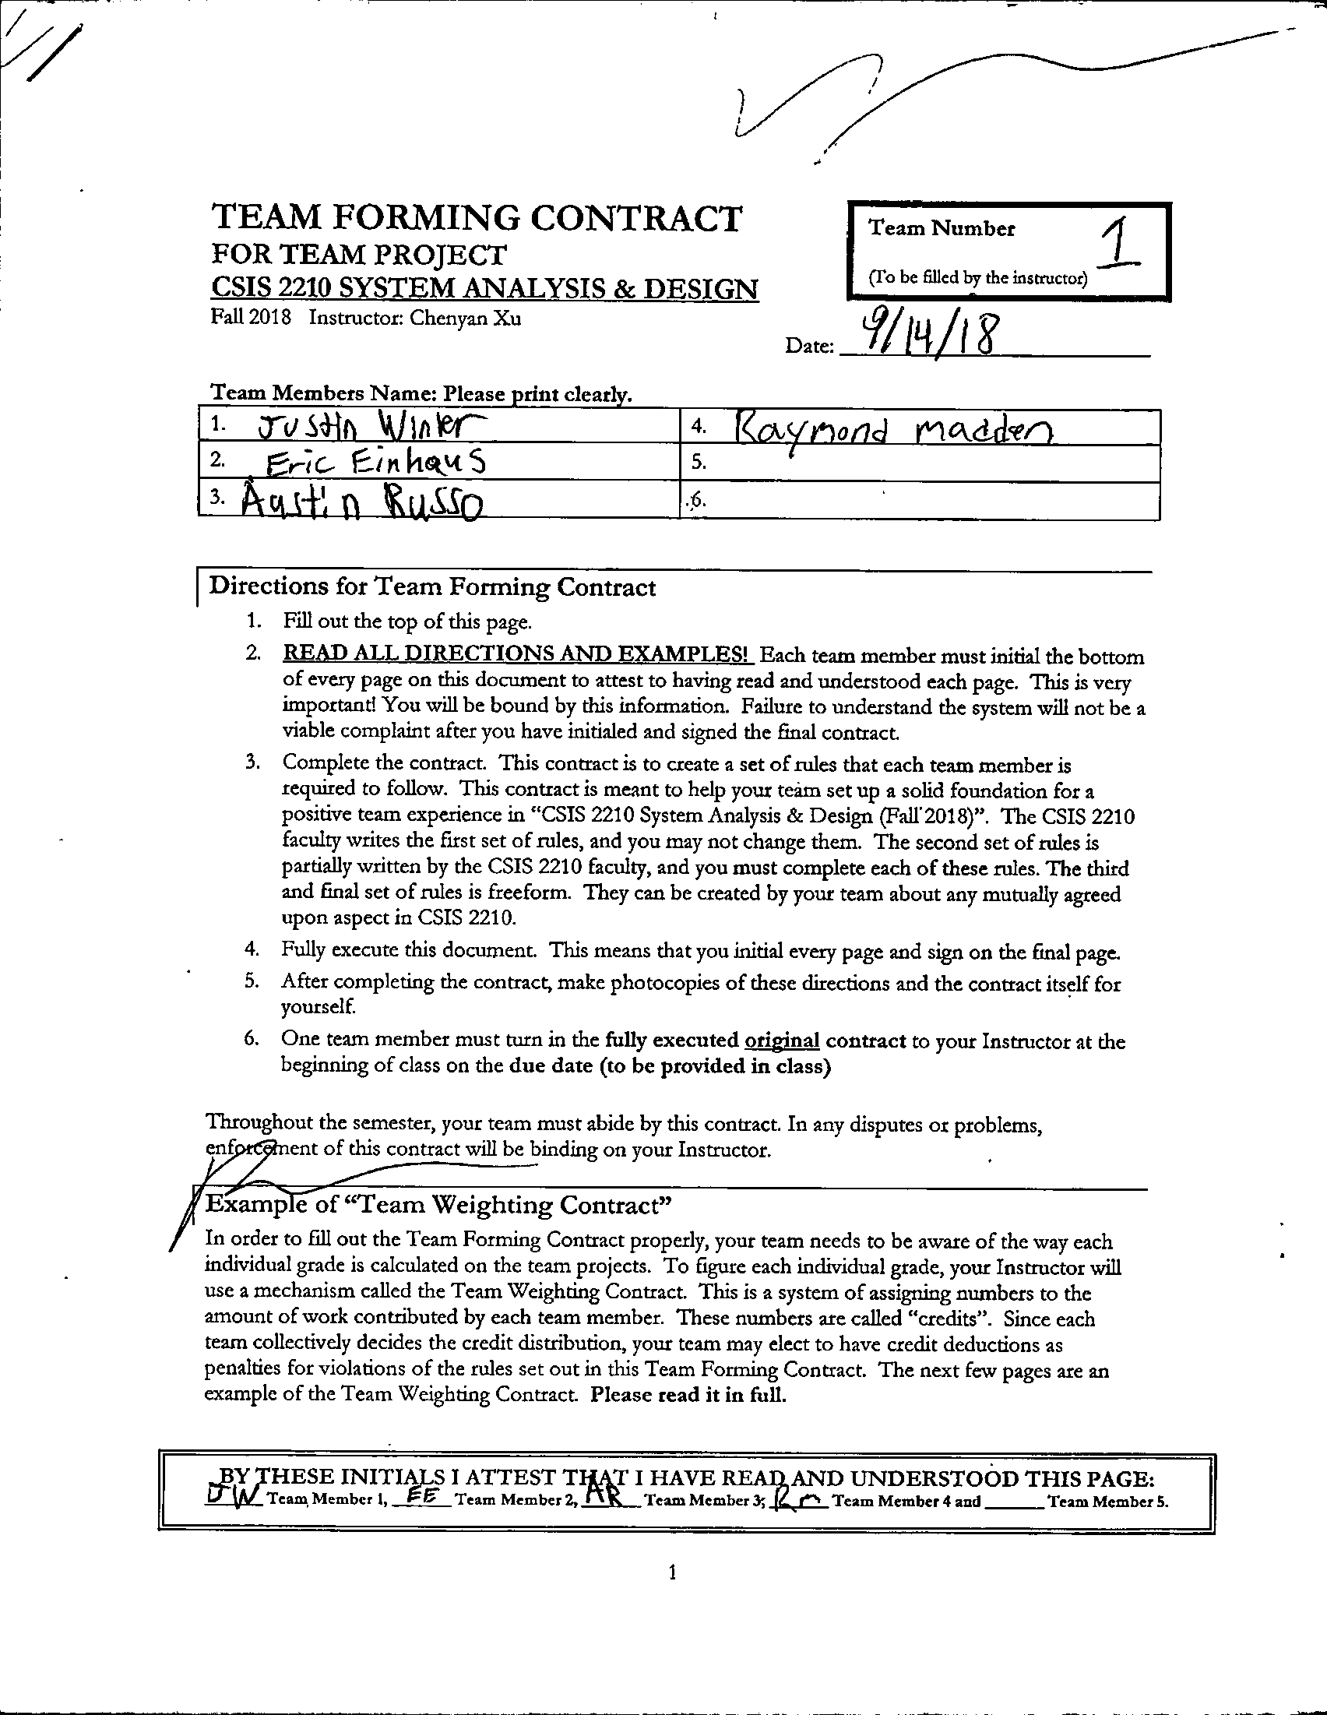

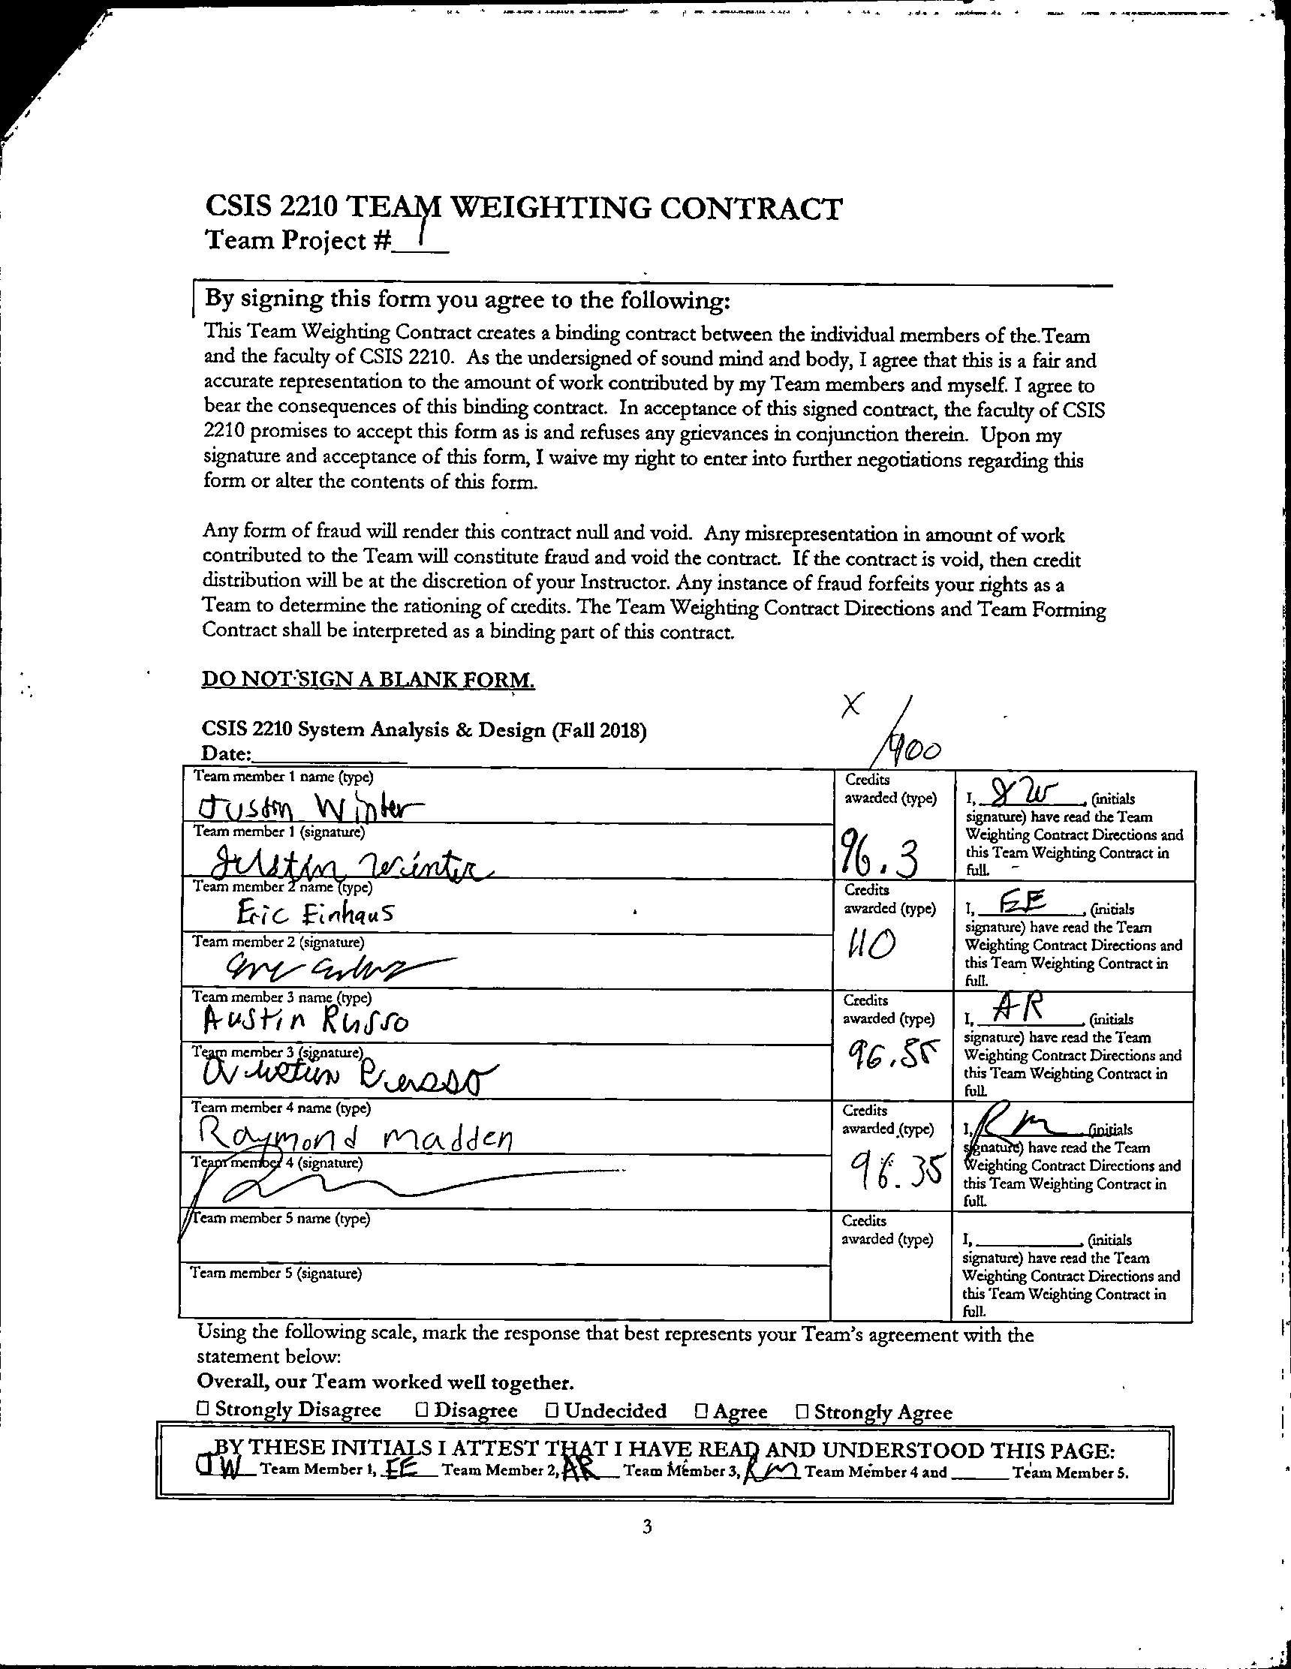

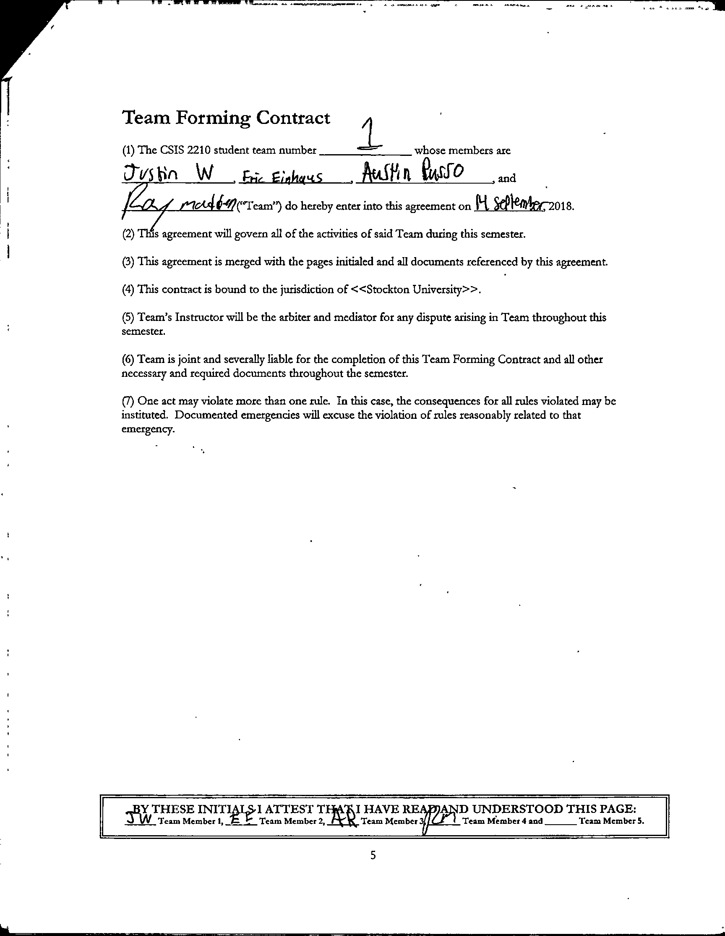

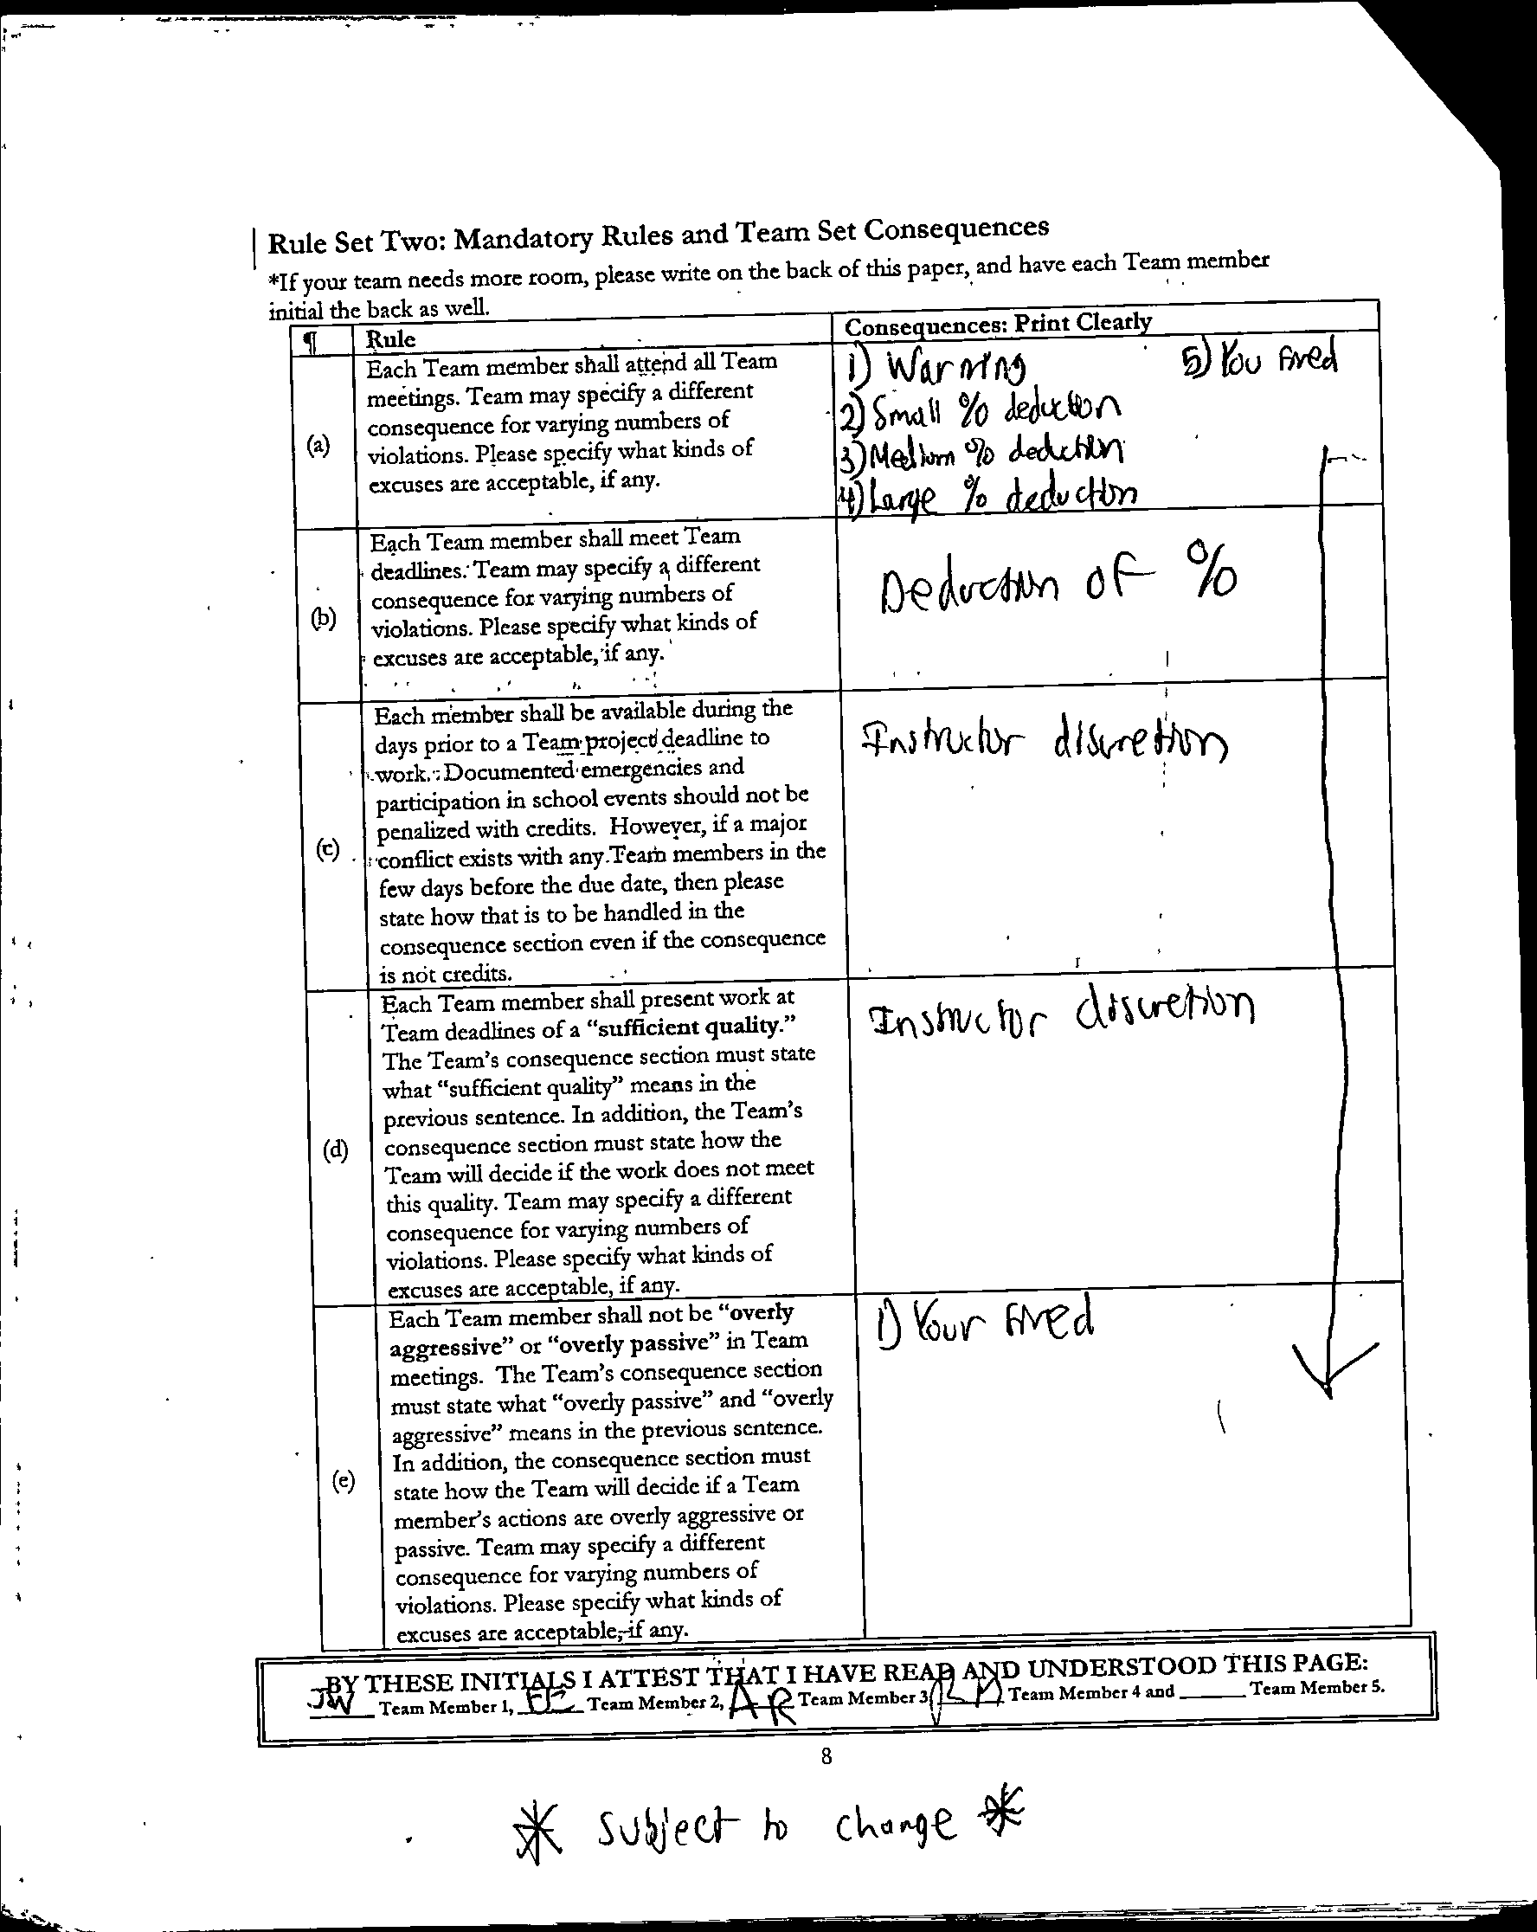

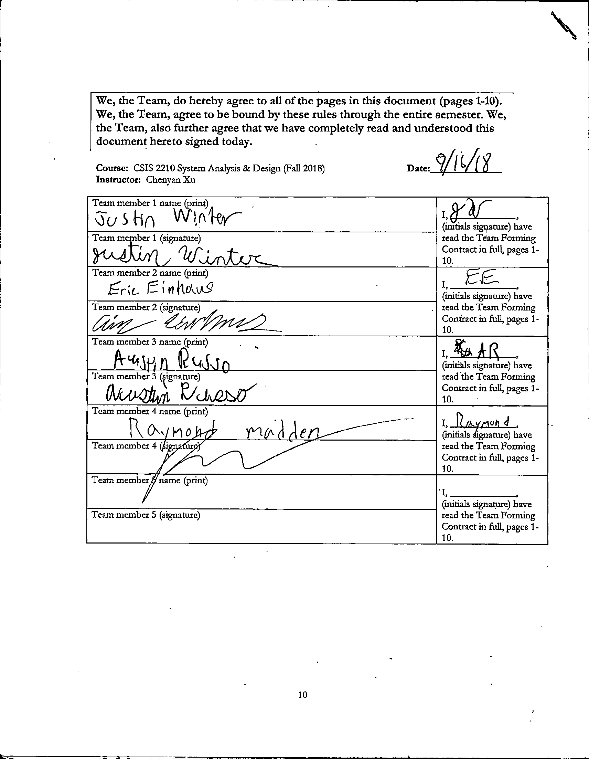

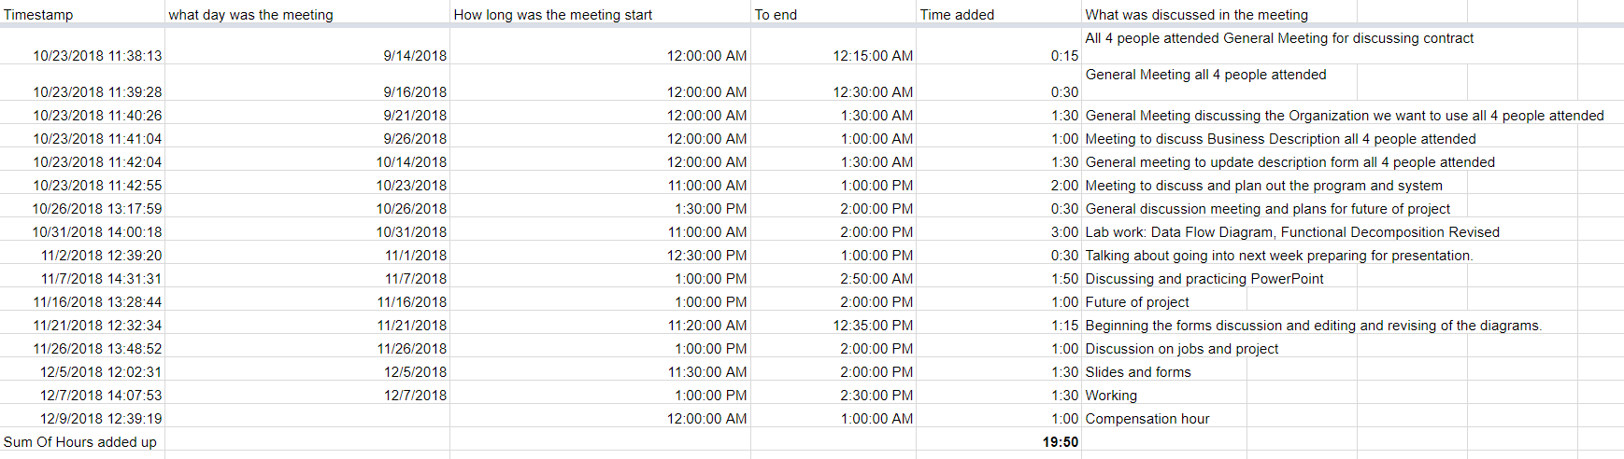

Meeting Minutes



